Army University Press - Combat Studies Institute
Wanat, 13 AUG 2008
Virtual Staff Ride
Table of Contents

Stand 1: Situation and Orientation 3
Stand 2: Chosen Company – Fifteen Months in the Waygal Valley 21
Stand 3: Occupation of COP Kahler 37
Stand 4: Enemy View of COP Kahler 51
Stand 5: The Attack on COP Kahler, 13 July 59
Stand 6: Counter-Attack and Withdrawal 73
Stand 7: Integration 79

Stand 1: Situation and Orientation

Visuals | Virtual Views
4. Strategic and Operational Context
5. Tactical Context
6. Physical and Human Terrain
7. Counter-Insurgency and 1-32 IN
8. Achieving Effects
9. Wanat vs. Aranas
10. High Angle Fires
11. Dead Space
12. Wanat vs. Aranas
13. COP Bella
14. Achieving Effects
15. 173rd Airborne Brigade Combat Team/TF Bayonet
16. Relief in Place/Transfer of Authority
17. 2-503 Infantry (TF Rock) 2007-2008
18. Commander’s Intent
19. Building on Success/TF Rock Disposition
20. Task Organization/Disposition of Platoons | 1. Asadabad
 | 2. COP Honaker-Miracle
 | 3. COP Able Main
 | 4. COP Michigan
21. FOB Blessing | 5. OP Hammerhead/FOB Blessing
22. Task Organization/Disposition of Platoons | 6. Wanat
23. COP Bella | 7. Bella
24. Aranas | 8. Aranas
25. COP Ranch House | 9. COP Ranch House
26. Troops in Contact
27. Limitations at COP Ranch House

ORIENTATION: Conducted in the stand.

DESCRIPTION:

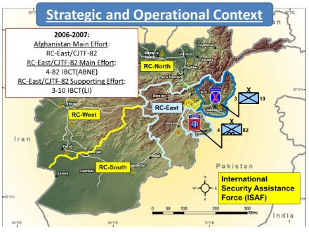
Slide 4. Strategic and Operational Context

- (4-1) Strategic Context: Iraq vs. Afghanistan. In 2006, the Main or Decisive Effort for the US Military was Operation Iraqi Freedom (OEF). Operation Enduring Freedom (OEF) in Afghanistan was the Economy of Force or Supporting Effort in the Global War on Terror. Supporting Efforts are a lower priority for resources and personnel.

- Operational Context.

  - (4-2) Afghanistan was divided into 5 Regional Commands (RCs).

  - In March 2006 RC-East was the OEF Main Effort and assigned to Combined Joint Task Force (CJTF) 82, composed of the 82nd Airborne Division Headquarters and its subordinate units.

    - (4-3) 4-82 Airborne Brigade Combat Team (ABCT) was an assigned subordinate unit of the 82nd Airborne Division. It replaced 3-10 Infantry Brigade Combat Team (IBCT) as the Main Effort in RC East.

    - (4-4) 3-10 IBCT, known as Task Force (TF) Spartan, had been responsible for all of RC-East before CJTF-82 arrived, but became a Supporting Effort and assigned the Nuristan, Laghman, Kunar, and Nangarhar Provinces in the eastern portion of the RC.
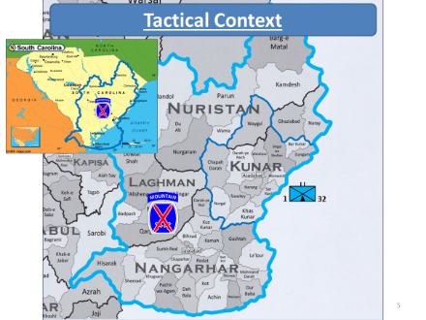
Slide 5. Tactical Context
- Tactical Context.

  - (5-1) TF Spartan conducted operations in RC East from March 2006 to February 2007. After they were attached to CJTF-82, their Area of Operations (AO) was much smaller (about half the size of South Carolina.)

  - Their presence in that part of Afghanistan marked the first continuous Coalition Forces (CF) presence since OEF started.

    - Prior to that, operations there were mostly raids conducted by Special Forces against High Value Targets (HVTs).

    - The gradual increase of CF presence resulted from the realization that the area served as a sanctuary for insurgent and terrorist organizations.

  - (5-2) 1-32 IN entered the Kunar-Nuristan area in April 2006 during Operation MOUNTAIN LION and established Combat Outposts (COPs) on the Pech River and its tributaries. Its counter-insurgency mission focused on denying insurgent access to the population.
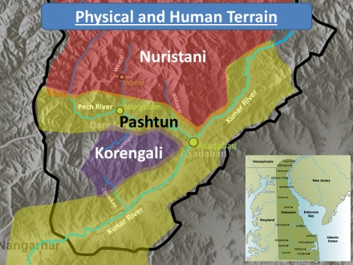
Slide 6. Physical and Human Terrain
    - (6-1) 1-32 IN’s AO comprised 2421 square miles (6271 square kilometers), an area about the size of Delaware.

    - Physical Terrain. The dominant physical terrain features in this area are the mountains and rivers.
      - (6-2) The Kunar River runs from northeast to southwest.
      - (6-3) The Pech River runs west to east and feeds into the Kunar River at Asadabad.
      - (6-4) Feeding the Pech are four smaller tributaries: the Chowkay, Korengal, Waygal, and Watapur Rivers.

    - Human Terrain. Three major ethnic groups reside here, and because they compete for scarce resources they are not always friendly with each other.
      - (6-5) The largest group are the Pashtuns. They live in the Kunar Valley as far north as Asadabad, and the Pech Valley west to Nangalam.
      - (6-6) North of Asadabad and the Pech Valley are the Nuristanis. Nuristanis identify with their families instead of their tribes, and their language has many different dialects.
      - (6-7) The smallest group are the Korengalis, who live in the river valley that bears their name.
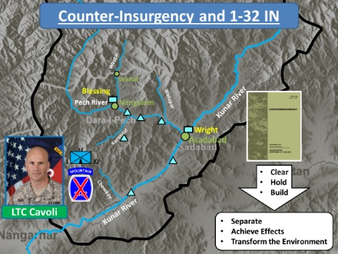
Slide 7. Counter-Insurgency and 1-32 IN
- Counter-Insurgency and 1-32 IN.

  - Emerging Counter-Insurgency Doctrine and LTC Cavoli’s Concept of Operations.

    - (7-1) FM 3-24, Insurgencies and Countering Insurgencies, was still in development when 1-32 IN moved into their AO. Lessons from Vietnam and earlier OEF and OIF experience recommended a “Clear-Hold-Build” approach to counter-insurgency when it was published.

    - (7-2) But “Clear-Hold-Build” requires large numbers of personnel, which Cavoli did not have as a Supporting Effort in RC-East.
      - Instead, Cavoli adapted those principles into something better suited to his limited resources.
      - Cavoli called his approach “Separate-Achieve Effects-Transform the Environment”.
        - Separate the Enemy from the Population.
        - Achieve Effects with the population and win their support with reconstruction projects and better governance.
        - Transform the Environment with roads, commerce, and the extension of the Afghan government so the enemy could no longer survive.

  - (7-3) Separate the Enemy from the Population. 1-32 IN occupied Camp Blessing, an existing FOB in the Pech Valley previously used by Marines and Special Operations units.

    - It was near the Pech District Center in the town of Nangalam.

    - (7-4) 1-32 IN established new COPs to protect their movement up the Pech River into FOB Blessing, then in the Pech and Korengal Valleys.

    - These COPs created “security bubbles” that enabled 1-32 IN to work on their second approach to counter-insurgency.

Slide 8. Achieving Effects
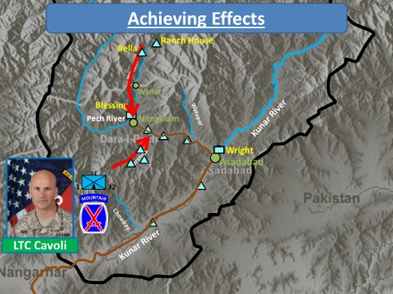
  - Achieving Effects.

    - (8-1) Cavoli made his Main Effort in the Pech Valley and started a project to pave the road between Nangalam and Asadabad. It was later extended from Asadabad to the Provincial Capital in Jalalabad.

    - (8-2) Additional COPs were established in the Korengal Valley and new COPs in the Waygal Valley to protect the project and secure avenues of approach into the Pech Valley.
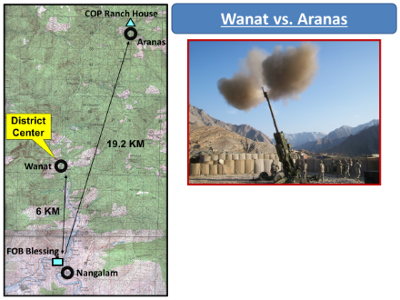
Slide 9. Wanat vs. Aranas
    - The two major villages in the Waygal Valley are Wanat and Aranas.
      - (9-1) The Waygal District Center is in Wanat and is about 6km from FOB Blessing.
      - (9-2) Aranas is a bigger village of about 6000 people, but is 19.2km from FOB Blessing.

LTC Cavoli recalled why 1-32 IN selected Aranas for a COP instead of Wanat:

Then Doug [CPT Sloan, B/1-32 IN Commander] went up to Aranas, where he discovered after many meetings with the elders that the town was split between hardcore terrorists and the locals, whom we call the “mujahideen faction”. The muj wanted the terrorist gone, but couldn’t do it themselves. So we asked them to invite us in and help them get rid of their rivals. . . they conferred all night, and then asked us in.

    - The selected site was called “Ranch House”.
      - Advantages of COP Ranch House.
        - Large population and known to harbor insurgents.
        - In a well-trafficked area where 1-32 IN could better influence other Nuristanis.
        - Located above and overlooking Aranas.
      - Disadvantages of COP Ranch House.
        - (9-3) Limited supporting fires from FOB Blessing.
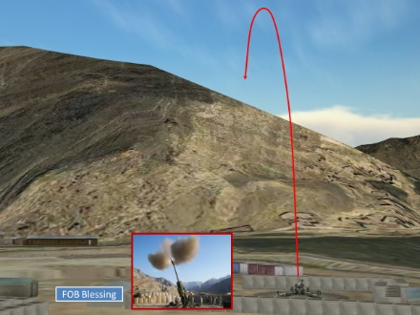
Slide 10. High Angle Fires
          - The two 155mm howitzers there can only range targets near the COP with high-angle fires.

Slide 11. Dead Space
          - High angle fires cannot engage targets on mountain slopes that face away from the gun-target line.

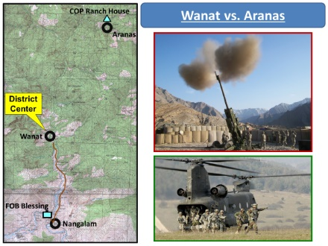
Slide 12. Wanat vs. Aranas
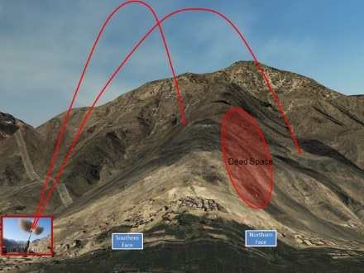
        - Limited means of sustainment. Two-lane roads from Nangalam into the Waygal Valley end at Wanat, and from there a one-lane road is only wide enough for HMMWVs and ends at Bella Village. Aranas can only be reached on foot or by air.
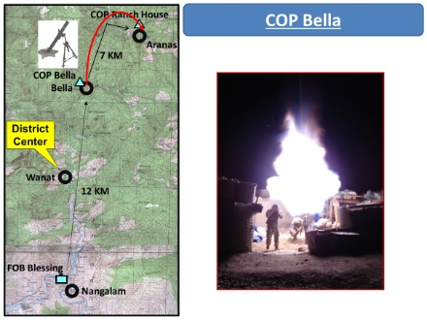
Slide 13. COP Bella
    - COP Bella.
      - (13-1) Bella Village is about 12km north of FOB Blessing, and can access Aranas via two foot trails.
      - (13-2) It was chosen for a COP to provide fire support to COP Ranch House with 120mm mortars. Those mortars could engage targets that the 155mm howitzers could not.
      - There were other advantages to putting a COP in Bella:
        - The village had the only functioning bazaar north of Wanat.
        - A Non-Government Organization (NGO) operated a medical clinic nearby. One of the nurses spoke English and regularly provided information to COP Bella.
        - It secured the foot trails leading to Aranas.
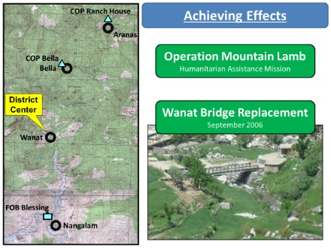
Slide 14. Achieving Effects
    - 1-32 IN accomplished two other major projects while in the Waygal Valley.
      - (14-1) Operation MOUNTAIN LAMB distributed humanitarian aid to Nuristanis and expanded CF access in remote regions.
      - (14-2) In Wanat, an engineer platoon attached to 1-32 IN used two sections of surplus World War 2 “Bailey Bridge” to replace a decrepit bridge over the Waygal River and lay a second bridge over the nearby Wayskawdi Creek.
        - They employed 50 locals for labor and provided them tools and materials for the bridge.
        - They purchased food for them from other locals and paid for their laundry.
        - Insurgents conducted probing attacks against the project, but could not disrupt the work.
        - The bridges were completed in about 45 days.

  - Transform the Environment.

    - The Pech River COPs protected the workers on the paving project.
      - As the road was completed, Improvised Explosive Device (IED) attacks reduced significantly. It was more difficult for insurgents to operate in villages that now sided with Coalition Forces.
      - There was better interaction with the population. It was easier to hold shuras (meetings) with local leaders to resolve grievances and establish functional relationships.
      - A paved road improved security and the local economy. Coalition Forces could move faster in the valley, and trade traffic could travel faster and farther.
      - A paved road was less subject to bad weather.

    - COPs in the adjacent river valleys degraded insurgent ability to influence the Pech Valley.

    - But Kunar/Nuristan remained a dangerous place for 1-32 IN even with those successes.
      - Three soldiers were killed in a direct fire engagement on 11 AUG 2006 while they patrolled between Aranas and Bella.
      - CPT Doug Sloan, who had proposed COP Ranch House, was killed on 31 OCT 2006 with three other soldiers on the road south of Bella. His death was mourned by the Afghans in the Waygal Valley.

LTC Cavoli viewed his battalion’s success, particularly in Wanat, as an example of progress when they redeployed in the spring of 2007:

I like Wanat quite a bit. The people were always good to us. They always gave us tips when trouble was coming. If felt very confident moving about without my armor on, and spent some memorable days drinking chai [hot tea] in the little chaykhana [tea shop] there. The key thing was the relationship that [First Lieutenant] Andy Glenn and his engineers had established when they were building the bridge. Glenn was great with the people, and they took him in like a brother. This made the place pretty safe, comparatively speaking.
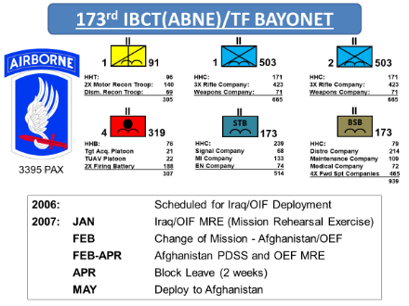
Slide 15. 173rd Airborne Brigade Combat Team/TF Bayonet
- 173rd Airborne Brigade Combat Team.

  - In 2007, the unit that replaced 3-10 IBCT in Afghanistan originally had deployment orders for Iraq.

  - It had started its Mission Rehearsal Exercise (MRE), the “dress rehearsal” for its deployment in Germany at the Joint Multi-National Training Center (JMRC) when it received the new orders for Afghanistan.

    - The Brigade’s commander, Colonel (COL) Charles Preysler and his key leaders conducted a standard Pre-Deployment Site Survey (PDSS) of 3-10 IBCT’s AO while the rest of the brigade remained behind at JMRC to finish their MRE.
Colonel Charles Preysler, Commander, 173rd Airborne Brigade Combat Team:
- Commanded 2-187 In during Operation ANACONDA in 2002.
- J3 for CJTF-76 in 2005-06 (which was replaced by CJTF-82).
- Very familiar with Afghanistan and RC-East from previous deployments.

    - With 3-10 IBCT they familiarized themselves with the new mission and the terrain. There were early discussions about closing some of 3-10’s COPs to improve the 173rd’s ability to maneuver.

  - (15-1) The 173rd had only three months to adjust and prepare for their new mission.

  - They adopted CJTF-82’s objectives and 3-10 IBCT’s methodology for counter-insurgency.

  - There were, however, some reservations about 1-32 IN’s disposition, particularly the extreme dispersal of troops on small, distant COPs.

  - (15-2) Also, because the 173rd was a Supporting Effort, one of its infantry battalions was detached to support 4-82 ABCT, which was the RC-East Main Effort.
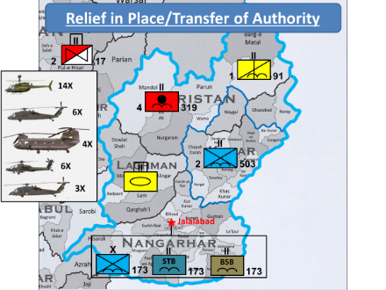
Slide 16. Relief in Place/Transfer of Authority
- Relief in Place/Transfer of Authority (RIP/TOA).

  - The 173rd, also known as TF Bayonet, took over 3-10 IBCTs AO in the spring of 2007.

    - The Brigade Headquarters, Special Troops Battalion (STB), and Brigade Support Battalion (BSB) were based at FOB Fenty in Jalalabad.

    - The Brigade Reconnaissance Squadron was sent to FOB Bostick and patrolled the Afghanistan/Pakistan border in the northeast.

    - The Field Artillery Battalion was based out of FOB Kala Gish in the north.

    - Later in the deployment, a National Guard Armor Battalion took over FOB Mehtar Lam.

    - 2-503 IN, now the only light infantry battalion in TF Bayonet, took over 1-32 IN’s AO and was based at FOB Blessing.

  - Attached to TF Bayonet was 2-17 Air Cavalry, based at Jalalabad.

    - It provided helicopter support to the brigade AO.

    - It had fourteen OH-58D Kiowas, lightly armed reconnaissance helicopters that could not operate at the higher altitudes north of the Pech River.

    - An air assault platoon of six UH-60 Blackhawks moved small numbers of personnel and supplies.

    - A heavy lift platoon of four CH-47 Chinooks moved larger numbers of personnel and supplies. It was the best helicopter for operations at high altitudes.

    - A platoon of six AH-64 Apache attack helicopters provided air attack and air support capability, but operated in three pairs:
      - One pair was always on 24-hour alert in Jalalabad as a Quick Reaction Force (QRF).
      - Two were usually tasked to escort the vulnerable Chinooks.
      - Two were usually undergoing routine maintenance or battle damage repair.

    - Three HH-60 air ambulances provided Air MEDEVAC support for wounded personnel.
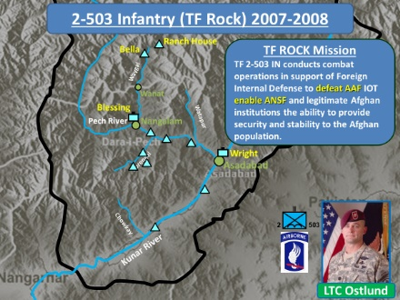
Slide 17. 2-503 Infantry (TF Rock) 2007-2008
- 2-503 IN (TF Rock).

  - Mission. TF 2-503 IN conducts combat operations in support of Foreign Internal Defense to defeat AAF IOT enable ANSF and legitimate Afghan institutions the ability to provide security and stability to the Afghan population.
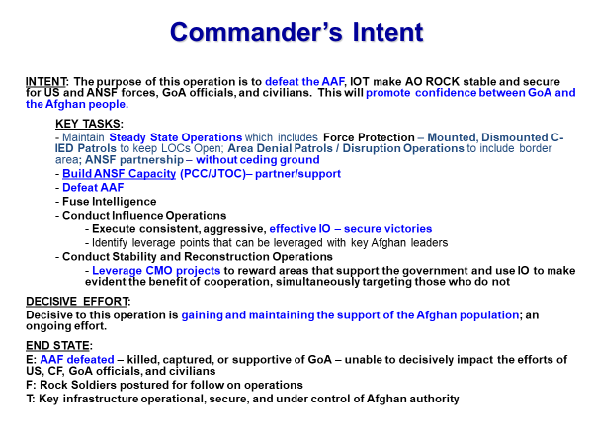
Slide 18. Commander’s Intent
  - Commander’s Intent.

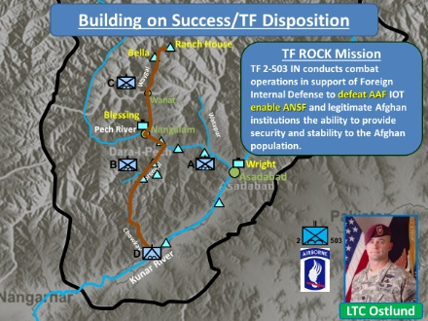
Slide 19. Building on Success/TF Rock Disposition
  - Building on Success: the Waygal-Korengal-Chowkay Road.

    - LTC Ostlund adapted 1-32 IN’s “separate-achieve effects-transform the environment” construct into one he called “separate-stabilize-engage”.

    - (19-1) The Pech-Kunar road was a guarded success for 1-32 IN. Positive trends tied to road building resulted in an idea for a second paved road from Aranas through Wanat to Nangalam, and from there through the Korengal and Chowkay Valleys to the Kunar Road.

    - TF Rock placed its companies and platoons to maintain 1-32 IN’s guarded success and expand it during their deployment.
Lieutenant Colonel William Ostlund, Commander, 2-503 IN:
- Prior service as an NCO in 1-75 Rangers.
- Rifle Platoon Leader in 101st Air Assault DIV during Operation DESERT SHIELD/DESERT STORM.
- Company Commander in Korea 1995-6.
- 1-508 IN S-3, 2002-3
- 173rd ABCT S-3 in northern Iraq, 2003 (COL Preysler commanded a battalion in the 173rd at that time).
- 173rd Deputy Brigade Commander, 2004.

  - Disposition of Companies.

    - (19-2) “Destined” Company, D/2-503 IN, was the battalion’s heavy weapons company. It was a Supporting Effort assigned the Kunar Valley and the southern end of the Chowkay Valley.

    - (19-3) “Able” Company, A/2-503 IN, was the battalion’s Main Effort in the Pech Valley.

    - (19-4) “Battle” Company, B/2-503 IN, was a Supporting Effort in the Korengal Valley.

    - LTC Ostlund’s battalion headquarters was on FOB Blessing.

    - (19-5) “Chosen” Company, C/2-503 IN, was a Supporting Effort in the Waygal Valley.
Slide 20. Task Organization/Disposition of Platoons
Virtual View 1. Asadabad
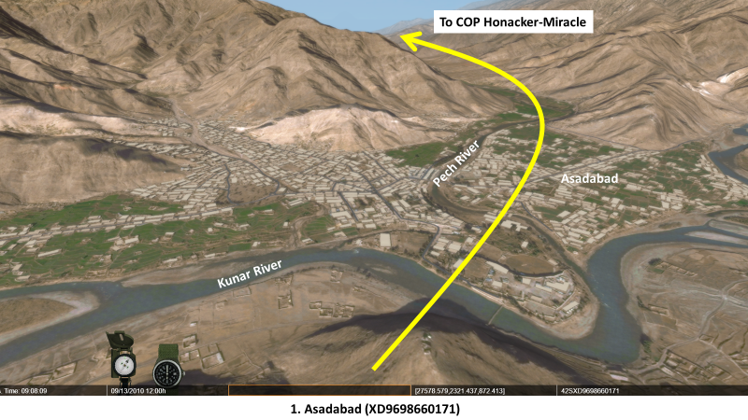
  - Disposition of Platoons. To better understand how LTC Ostlund deployed his battalion, you also must look at how his four companies were task organized.

    - (20-1) Destined Company/Kunar Valley. A mounted heavy weapons company has four platoons, each with four HMMWVs carrying either a TOW anti-tank missile launcher, a .50 cal heavy machine gun, or a Mk19 40mm grenade launcher. The weapons crews are small, generally only three or four soldiers per vehicle.
      - The company Command Post (CP) and one platoon were on Fire Base (FB) Fortress augmented by a light infantry platoon from Chosen Company.
      - A second platoon manned COP Chowkay with a partnered Afghan National Army (ANA) platoon.
In the virtual view, you are looking at Asadabad where the Pech River flows into the Kunar River. Note how the agricultural fields are in the river bottom and the village buildings are up on the mountainsides. Asadabad is the north end of Destined Company’s AO. Able Company’s AO starts west of Asadabad in the Pech River Valley.
Move up the Pech Valley as indicated by the yellow arrow until you reach COP Honaker-Miracle.
    - (20-2) Able Company/Pech Valley. Light or airborne infantry rifle companies have three rifle platoons of about 48 soldiers each armed with carbines, automatic rifles, light machine guns, grenade launchers, 60mm mortars, and limited anti-armor capability. As TF Rock’s Main Effort, it retained all three rifle platoons and was augmented by one of Destined Company’s weapons platoons.
      - One platoon manned COP Honaker-Miracle with a partnered ANA platoon.
Virtual View 2. COP Honaker-Miracle
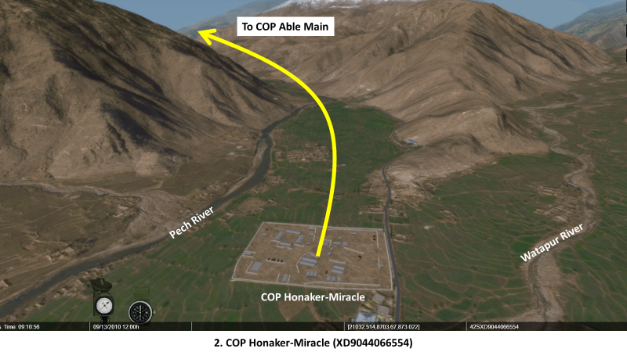
In the virtual view, re-emphasize the agricultural fields in the bottom of the Pech River Valley. Point out the Watapur River Valley on the right, one of the insurgents’ avenues of approach. Discuss possible threats to the COP and what kinds of weapons insurgents might use to attack it. COP Honaker-Miracle had overhead cover on every walkway between buildings to mitigate risk from frequent small arms fire attacks.
Continue to move up the Pech Valley as indicated by the yellow arrow until you reach COP Able Main.
      - The company CP and a second platoon were on COP Able Main with the attached weapons platoon. The partnered ANA company CP and one of its platoons was also located here.
Virtual View 3. COP Able Main
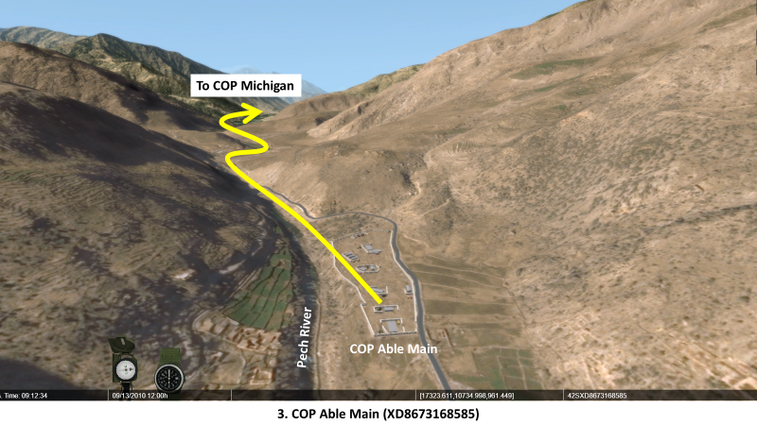
In the virtual view, point out how the valley floor has started to narrow from a U-shaped bottom to a V-shaped bottom.
Continue to move up the Pech Valley as indicated by the yellow arrow until you reach COP Michigan.
      - The third platoon manned FB Michigan with its partnered ANA platoon.
Virtual View 4. COP Michigan
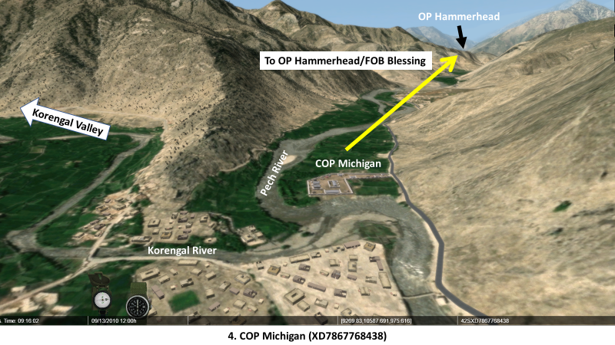
In the virtual view, point out the where the Korengal River feeds into the Pech River. The Korengal Valley is where Battle Company’s AO begins. There is no need to move up into the Korengal Valley. If time permits, mention the events surrounding OP Restrepo and the documentary depicting the events that occurred there. You could also discuss the events of Operation REDWINGS, the SEAL mission that also occurred in the Korengal Valley. US Navy Lieutenant Mike Murphy received the Medal of Honor for his actions in that engagement, and the story of REDWINGS is depicted in the movie “Lone Survivor”.
    - (20-3) Battle Company/Korengal Valley. Battle Company kept all three of its platoons and was augmented with the fourth platoon from Destined Company.
      - One platoon was close to the valley’s mouth on FB Vegas with an ANA weapons platoon.
      - The company CP was on Korengal Outpost with the second platoon and the attached weapons platoon. An ANA weapons company headquarters and two of its platoons were also placed there.
      - The third platoon was deep in the valley at FB Vimoto with the fourth ANA weapons platoon.
Continue to move up the Pech Valley as indicated by the yellow arrow to OP Hammerhead overlooking FOB Blessing. Match the view in the slide to the view in the virtual terrain.
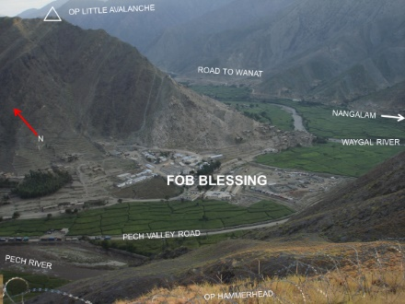
Slide 21. FOB Blessing
    - TF Rock CP/FOB Blessing.
      - TF Rock’s headquarters was here with its partnered ANA battalion headquarters and one of its companies.

Virtual View 5. OP Hammerhead/FOB Blessing
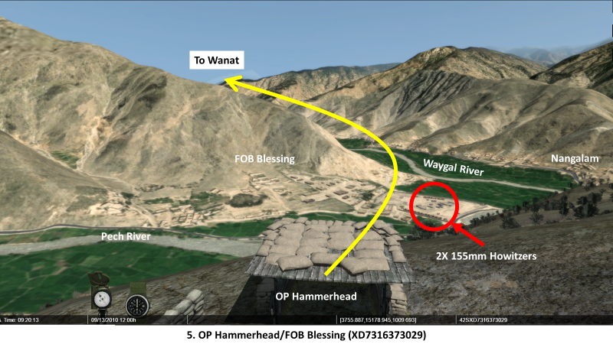
Point out the location of the two 155mm howitzers on FOB Blessing.
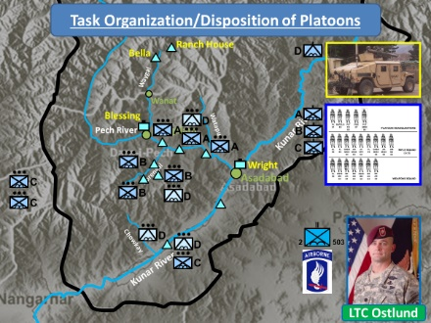
Slide 22. Task Organization/Disposition of Platoons
      - (22-1) The battalion QRF, one of Chosen Company’s three infantry platoons, was also located here.
Have the terrain tech switch to the Battalion North Database.
    - (22-2) Chosen Company/Waygal Valley. Chosen company retained only one of its platoons for the two COPs in its AO.
      - That platoon would swap QRF duties with the one on FOB Blessing on a regular basis to give its soldiers an opportunity to rest and maintain themselves and their equipment.
      - The platoon in the Waygal Valley was divided into two sections. One section was on COP Bella, and the other section on COP Ranch House.
Move north up the Waygal Valley as indicated by the yellow arrow until you reach Wanat.
Virtual View 6. Wanat.
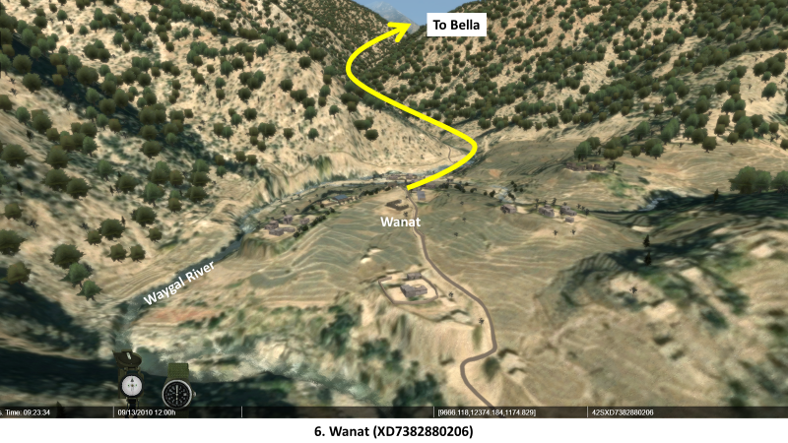
In the virtual view, point out the Waygal River on the left, and emphasis that the road north of Wanat is only wide enough for HMMWVs. If HMMWVs are on that road, no other traffic can pass on it until they reach Bella.
Continue north up the Waygal Valley as indicated by the yellow arrow until you reach Bella. Match the view in the slide to the view in the virtual terrain.
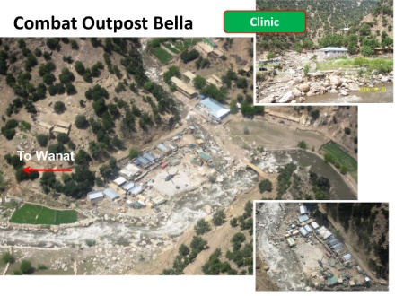
Slide 23. COP Bella
      - COP Bella.
        - About 24 soldiers were here to support COP Ranch House with the 120mm mortars.
        - It had three Observation Posts (Ops) around it on higher ground for security.
Virtual View 7. Bella.
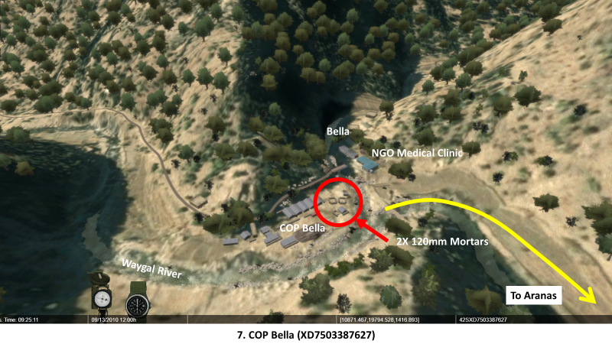
In the virtual view, point out the Helicopter Landing Zone (HLZ) that is only large enough for one helicopter. Point out the 120mm mortars and the NGO medical clinic. The next village, Aranas, is only accessible from this point by two foot trails or by air.
Continue north up the Waygal Valley as indicated by the yellow arrow and enter the valley on your right. You should be able to make out the two foot trails. One follows the top of the ridge on the right and the other follows the valley floor. Match the view in the slide to the view in the virtual terrain.
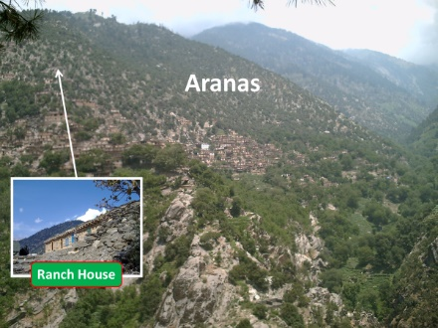
Slide 24. Aranas

Virtual View 8. Aranas
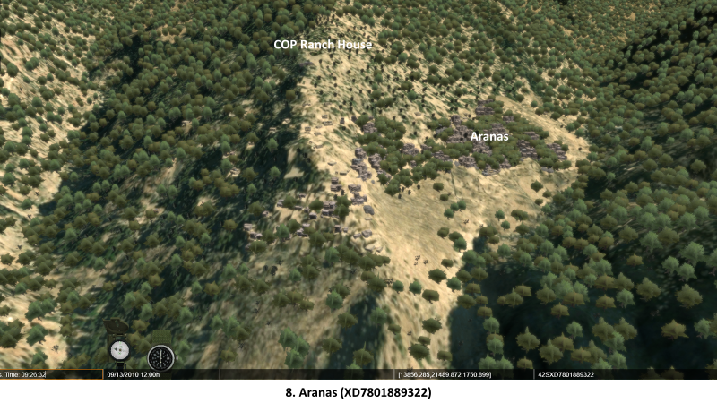
In the virtual view, point out how the entire village is on the mountain slope.
Zoom in on COP Ranch House. Match the view in the slide to the view in the virtual terrain.
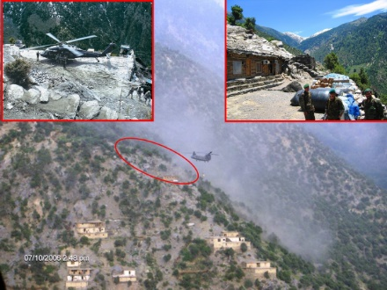
Slide 25. COP Ranch House
      - COP Ranch House.
        - About 24 US soldiers and 22 ANA soldiers manned six positions: five OPs and the CP.
        - Fifteen Afghan Security Guards (ASGs) were responsible for the eastern OP. They were typically low-quality locals from Aranas and served as gate guards.
Virtual View 9. COP Ranch House
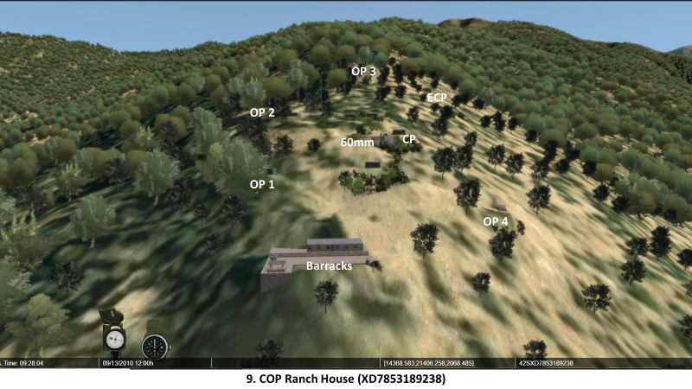
In the virtual view, point out the COP’s Entry Control Point (ECP), OPs, and CP.
ANALYSIS.
- LTC Ostlund adopted most of the practices used by LTC Cavoli. What did Ostlund change after RIP/TOA?

  - The disposition of platoons was different from that used by 1-32 IN.

  - The focus for road projects shifted to the Waygal/Korengal/Chowkay Valleys.

- What limitations did Ostlund face? Were they any different from Cavoli’s limitations?

  - 2-503 IN was spread out over a large geographic area in platoon-sized positions.

  - Some positions were only accessible on foot or by air.

  - Terrain and weather had substantial impacts on operations.

  - Chosen Company’s AO was covered by one platoon split between two locations.

  - Ostlund’s limitations were basically the same ones Cavoli faced.

    - Cavoli only had enough forces to transform the Pech and Kunar Valleys. He was concerned that insurgents from beyond his reach would reverse the successes in the Pech.

    - Ostlund shifted his focus for development and roads to the Waygal/Korengal/Chowkay Valleys. He was constantly concerned that he did not have enough flexibility for his battalion; all but one platoon was tied to a piece of ground and one of his platoons could only be sustained by air.
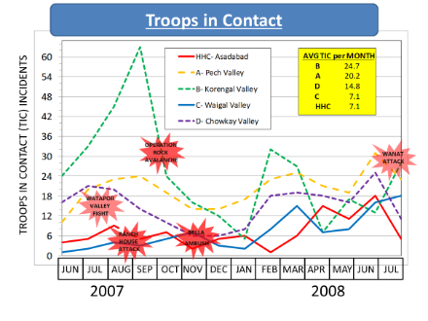
Slide 26. Troops in Contact
- Is it an acceptable risk to place one platoon in the Waygal Valley when so many other positions in RC-East are similarly disposed?

  - In 2007 and 2008, the Korengal Valley accounted for about 40% of TF Rock’s actions with insurgents, called “Troops in Contact” (TICs). On average, Battle Company was engaged almost once per day.

  - By comparison, Able Company (the TF Main Effort) in the Pech Valley accounted for slightly less than 30% of all TICs. On average, Able Company was engaged every one or two days.

  - Destined company was engaged every other day.

  - Chosen Company’s platoon in the Waygal was engaged about once every four days.

  - Given the level of activity compared with the other companies and the types of attacks endured, placing one platoon in the Waygal Valley could be considered an acceptable risk for a Supporting Effort.
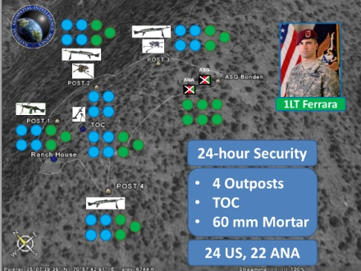
Slide 27. Limitations at COP Ranch House
- What limitations does that platoon face?

  - The platoon is divided between two isolated locations.

  - (27-1) There are six positions to man at COP Ranch House with 24 US soldiers – four per position, but nine per position if you include the ANA platoon.

  - (27-2) They must maintain 24-hour security, which if split between two 12-hour shifts reduces the number per position from four US to two US soldiers – or four if you include the ANA platoon.

  - They must absorb absences from sickness, injury, block leave, etc. that further reduces combat power on any given day.

  - If the platoon conducts a patrol or has a shura in Aranas, the number per position drops even further and must include the ANA platoon.

- Is it feasible to conduct counter-insurgency with Ostlund’s framework those limitations as a platoon leader? What courses of action are suitable to minimize the effect of those limitations on your mission?

Stand 2: Chosen Company – Fifteen Months in the Waygal Valley

Visuals | Virtual Views
29. Chosen Company in the Waygal Valley | 9. COP Ranch House
30. (Untitled)
31. (Untitled)
32. (Untitled)
33. Chosen Company in the Waygal Valley | 10. Ambush Site
 | 11. COP Bella
 | 12. OP Speedbump
34. Chosen Company in the Waygal Valley
35. 4 July Mortar Attack and Apache Strike
36. CONOP ROCK MOVE
37. ROCK MOVE (Wanat) – MLCOA & MDCOA
38. Chosen Company Task Organization
39. ROCK MOVE ISR Optimization
40. WANAT: TF 2-503, 8-9 JUL 2008 Concept of Lethal Fires
41. CONOP ROCK MOVE
42. (Untitled) | 13. Wanat North
43. (Untitled) | 14. Wanat East
44. (Untitled) | 15. Wanat West
45. (Untitled) | 16. Wanat South

ORIENTATION. Use the same view of COP Ranch House from the end of Stand 1.

DESCRIPTION.

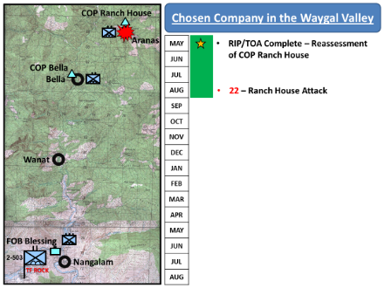
Slide 29. Chosen Company in the Waygal Valley

- Actions in the Waygal Valley, 2007-08.

  - RIP/TOA was complete in May 2007 and TF Rock assumed control of their AO, but reassessed their platoons’ disposition and considered repositioning some of the COPs that were farthest away.

  - CPT Matthew Myers’ Chosen Company was responsible for the Waygal Valley, but only had one platoon available for COPs Ranch House and Bella at any given time.
Captain Matthew Myer, Commander, C/2-503 IN:
- Son of a 27-year infantry veteran.
- USMA Class of 2001.
- Deployed to Iraq 2003 with 4th Infantry Division.
- Well regarded by his peers and known for a calm, contemplative leadership style.

  - TF Rock considered closing COP Ranch House during the PDSS but delayed any action until after RIP/TOA.

    - Brigade and battalion leadership continued to re-evaluate extended positions established by 3-10 IBCT, which included the two COPs in the Waygal Valley.

    - Some on the brigade staff thought 3-10 IBCT had gone “too far, too fast” with positions in the steep isolated valleys of Afghanistan that were difficult to supply and secure.

  - Faced with the high degree of enemy activity in the Korengal Valley, LTC Ostlund wanted more flexibility to maneuver his companies by withdrawing from Ranch House and Bella.

    - But he did not want to give the insurgents and Information Operations (IO) “win” doing so, even though enemy activity in the Waygal was relatively light.

    - He did not want insurgents to claim they had driven his men out.

    - Therefore, the platoon remained at Ranch House and Bella.

  - (29-1) 22 AUG 2007: The Attack on COP Ranch House.

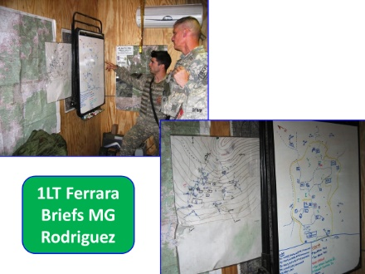
Slide 30. (Untitled)

    - 1LT Matt Ferrara’s 1st Platoon had a relatively uneventful summer while discussions continued about their possible relocation.
      - In this photo he is seen briefing MG Rodriguez, the CJTF-82 Commander.
      - The COP Ranch House perimeter sketch is on the wall.

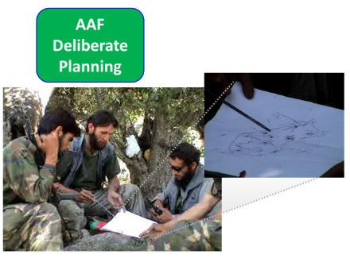
Slide 31. (Untitled)

    - But this photo shows insurgents with what looks like an accurate copy of Ferrara’s perimeter sketch.

    - How could insurgents get that information without access to Ferrara’s CP?

    - There are two possible explanations.
      - First, the information was obtained from ASG members. They were locally recruited from Aranas and poorly trained. Many quit after serving for only a short time. They may have deliberately or carelessly provided information to insurgents about the perimeter.
      - Second, it may have been the result of a cultural vendetta. CPT Myer publicly fired the ASG Commander for incompetence in early August. Culturally, this was a personal insult in the honor-conscious culture of Afghanistan, and may have resulted in the ASG Commander seeking revenge via providing the perimeter information to insurgents.

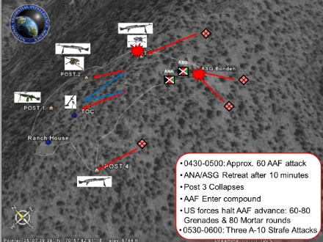
Slide 32. (Untitled)

Instructor note: there are no specified movements or virtual views for discussion the COP Ranch House attack other than the one depicted in #9 COP Ranch House. But instructors are free to move about the terrain as they see fit to emphasis particular aspects of the engagement.

    - The attack began at 0430.
      - (32-1) About 60 insurgents crept up from Aranas and attacked the ECP and OP 3 with Rocket-Propelled Grenades (RPGs) and small arms fire.
      - (32-2) After about 10 minutes’ fighting, the ANA and ASG at the ECP retreated to OP 4 and the barracks.
      - (32-3) OP 3 collapsed after continuous RPG fire, and trapped one soldier beneath it who was rescued later.
      - (32-4) Insurgents entered the perimeter and fired on the western defensive positions.
      - (32-5) SSG Phillips, the mortar section leader, and SSG Dzwik, the weapons section leader, gathered the soldiers who were not wounded and established a defensive position just above the CP.
      - They disrupted the insurgent attack with 60-80 hand grenades and 80 rounds from the 60mm mortar.
      - The insurgents wore Battle Dress Uniforms (BDUs) like those worn by the ASG. This made the fight very confused. They were too close to safely fire on them with the 155mm howitzers at FOB Blessing or the 120mm mortars at COP Bella.
      - (32-6) After an hour of fighting, two A-10s responded to the emergency Close Air Support (CAS) request and made three strafing attacks on the insurgents. They withdrew back into Aranas.
      - The Ranch House attack resulted in eleven US wounded, but one ANA and one ASG were killed in the engagement.

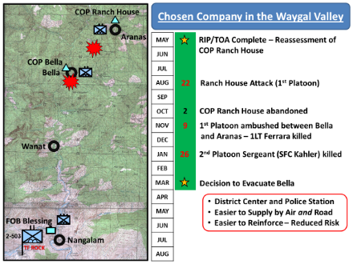
Slide 33. Chosen Company in the Waygal Valley

  - (33-1) 2 OCT 2007: Ranch House Evacuated.

    - TF Rock decided to close COP Ranch House after the 22 AUG attack, but delayed the closure until October.
      - October was the last month before weather started to negatively impact air movement.
      - The delay allowed TF Rock to proactively counter insurgent propaganda that they “had been driven out”.
      - But after Ranch House was evacuated, insurgents filmed a mock attack on the empty position and still claimed they drove the Americans out.

    - The platoon consolidated at COP Bella, where they could still execute their mission in the Waygal Valley.

Instructor Note: If you did not move from Virtual View 9 in the previous discussion, rotate 180 degrees and look down the valley from COP Ranch House. If you did, hover over the Ranch House barracks and look east down the valley.

Virtual View 10. Ambush Site

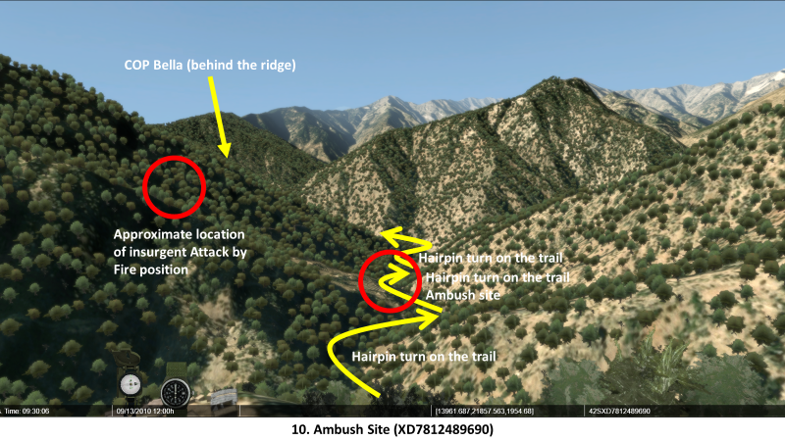

  - (33-2) 9 NOV 2007: 1LT Ferrara Ambushed.

    - On an invitation from the village elders in Aranas, Ferrara organized a ground movement from COP Bella to the village for a shura.

    - When the reinforced squad arrived in Aranas, the village elders said they had no knowledge of inviting them to a shura.

    - The reinforced squad was ambushed returning to COP Bella.
      - Five US soldiers are killed, including 1LT Ferrara, and eight are wounded.
      - Two ANA are killed and three wounded. Their Embedded Tactical Trainer (ETT), a US Marine, is also killed.

Show the video clip “COP Bella”. Point out the difference between COP Ranch House’s position on commanding terrain versus Bella’s vulnerabilities in the river valley.

In the virtual view, point out the approximate ambush site on the second hairpin turn on the trail where it bends around one of the spurs. Also point out the approximate location of the insurgent Attack by Fire position. The second trail is from Bella to Aranas is in the same general area.

You are free to move around the valley and explore the ambush site and the attack by fire position.

    - In contrast to CPT Sloan’s death the year before, no condolences are offered for Ferrara or his men.

Move down the valley and turn left (south) back to an overhead view of COP Bella. Take up a position just above the CH-47 Chinook similar to the view below.

Virtual View 11. COP Bella

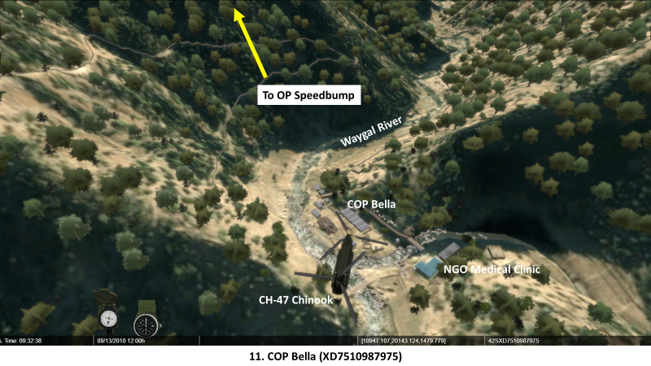

    - Shortly after the ambush, 2nd Platoon rotated into Bella and 1st Platoon returned to FOB Blessing. Their platoon leader is 1LT Jonathan Brostrom, who was new to Chosen Company.

    - Before the end of November, LTC Ostlund tried to influence the population in Aranas and nearby villages by freezing all development projects planned for the area.
First Lieutenant Jonathan Brostrom, 2nd Platoon Leader, C/2-503 IN:
- University of Hawaii ROTC, Class of 2006.
- Assigned to Italy after graduating Ranger School.
- Deployed to Afghanistan in June 2007.
- TF Rock’s Assistant Operations Officer for about 4 months.
- Platoon Leader for 2nd Platoon in November 2007.
      - He made it clear that unless the leaders in Aranas assisted CF in driving out the insurgents, they would not get any development projects.
      - It was hoped that as the elders in Aranas saw Bella and Wanat benefit from projects, they would stop supporting insurgents and side with CF and the Afghan Government.

Continue to OP Speedbump as indicated by the yellow arrow.
Virtual View 12. OP Speedbump

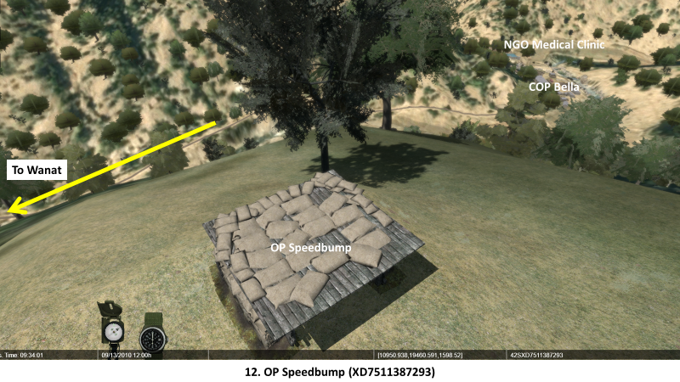

In the virtual view, point out how high on the mountain slope COP Bella’s OPs are, and how much physical effort is required to reach them.

  - (33-3) 26 JAN 2008: SFC Kahler Killed.

    - Early that morning SFC Matthew Kahler, Brostrom’s platoon sergeant, led a pre-dawn patrol to check on the ASGs in the OPs surrounding COP Bella on the mountainsides.

    - The ASG were known to fall asleep or leave their posts to warm themselves over a stove or fire.

    - OP Speedbump’s ASG was not responding to radio checks, and as the patrol got closer Kahler stepped to the front and warned, “This could be dangerous.”

    - Then as moved forward and called out to the guard, the guard suddenly leaned out and fired his weapon, killing Kahler.

    - The following AR 15-6 investigation ruled the shooting an accident, but many in 2nd Platoon believed the guard deliberately shot their platoon sergeant.

    - Again, in contradiction of local traditions, there were no condolences offered for SFC Kahler’s death.

  - After these incidents, there were indications that Chosen Company no longer trusted the people of the Waygal Valley or the ASG.

  - (33-4) MAR 2008: Decision to Close COP Bella.

    - COL Preysler directed his staff to start work on closing COP Bella and establish a new COP in Wanat. The Wanat location had several advantages:
      - It was a Nuristani village closest to government and military facilities in the Pech Valley.
      - (33-5) The Waygal District Center and Afghan National Police (ANP) are located there.
      - (33-6) Wanat could be sustained by air and by road.
      - (33-7) Presence in Wanat allowed TF Rock to continue their mission in the Waygal Valley with more flexibility and less risk than maintaining isolated COPs farther north.

    - About this time, TF Bayonet had its deployment extended for three months.
      - This created pressure in TF Bayonet and TF Rock to finish construction of the Wanat COP before their relief arrived.
      - 1st Infantry Division’s 1-26 IN would replace 2-503 IN, but MTOE differences meant 1-26 IN would take over the same AO with fewer soldiers.
      - The initial date for construction was set for early June, but was delayed until 1 JUL because construction contractors were not available until then.

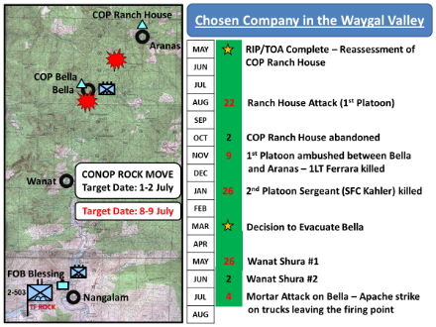
Slide 34. Chosen Company in the Waygal Valley

  - JUN 2008: TF Rock Negotiates in Wanat.

    - While TF Bayonet planned the move, TF Rock started negotiating with Wanat elders for land use in the village to build the COP.
      - (34-1) 26 May: Shura #1. Ostlund and Myer met with Wanat elders, and this first meeting did not go well.
        - Ostlund and Myer felt they were being “put off” and that the meeting was being deliberately drawn out.
        - In a gross violation of well-established cultural traditions, the elders did not eat lunch with their guests.
        - After Ostlund and Myer left Wanat, their ground convoy was ambushed and two soldiers were wounded.
      - (34-2) 8 June: Shura #2. This meeting was even less productive.
        - Some of the notes Ostlund prepared for it were very sternly worded.
        - Clearly, there were elements within the population of Wanat and the valley that did not want Coalition forces to establish a base in their town.

    - (34-3) As the 1 July date approached, the move to Wanat was again delayed by a request from TF Out Front, who supported the move with helicopters. They needed the date shifted to 8 July for optimal illumination conditions for their Night Vision Goggles (NVGs).

  - (34-4) 4 JUL 2008: Mortar Attack on COP Bella.

    - On 3 July, a soldier at COP Bella was wounded by mortar fire.

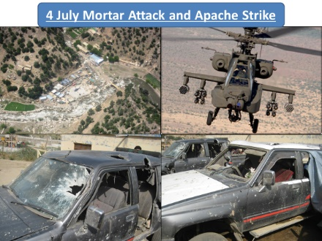
Slide 35. 4 July Mortar Attack and Apache Strike

    - When another mortar attack occurred on 4 July, CPT Myer directed two AH-64 Apaches to fire on a truck reported to carry the mortar and the crew.
      - OP #1 identified a truck carrying a mortar moving south away from COP Bella. The Bella OPs, because they are on the high ground, were in an excellent position to observe the attackers.
      - The Apaches engaged that truck and a second truck, destroying both.
        - Several known insurgents, including the local leader in the Waygal District, Mullah Osman were wounded and others killed.
        - This was later confirmed by signals intelligence (SIGINT).
      - The Regional Government claimed 22 non-combatants (including a guard at the NGO medical clinic in Bella) were killed. An IO fight began.
        - Hamid Karzai, President of Afghanistan, sacked the Provincial Governor for criticizing the incident on Al Jazeera television.
        - A standard-practice AR 15-6 investigation was started. The results were inconclusive, but the impacts on the community were widely felt.

    - CPT Myer’s role in the 15-6 prevented him from being physically present with 2nd Platoon until after it occupied Wanat.

Another former Waygal resident, Sami Nuristani, felt there was a direct correlation between the Apache attack at Bella and the subsequent attack on Wanat:

I think July 4 was a disaster both for the people of Waygal Valley and the Coalition forces. The aftermath of the Bella incident led to the [Wanat] attack, the link is very obvious[ly] mostly caused by the anger over the death of innocent civilians in Bella. I have known two of the deceased in that incident. Most people believe that the locals were so angered by the Bella incident that they even cooperated (or simply did not report to the Americans) with those who attacked the [Wanat] outpost. The attack certainly changed people’s support for the US Army given the fact that they killed the very people who had helped them or were very cooperative to them.

  - While TF Bayonet finished its plans for the move and TF Rock contended with strained relations and their upcoming redeployment, the RIP/TOA with 1-26 IN began.

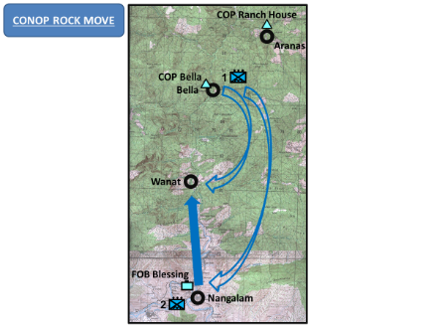
Slide 36. CONOP ROCK MOVE

- CONOP ROCK MOVE.

  - The general concept for CONOP ROCK MOVE was simultaneous moves between COP Bella, COP Wanat, and FOB Blessing.

    - (36-1) 1st Platoon would use two lifts, first for equipment and second for personnel to FOB Blessing.

    - (36-2) 2nd Platoon would use a mounted ground movement in HMMWVs to Wanat, occupy the COP site, and begin initial construction of the defenses and fighting positions.
      - Myer and Brostrom discussed the operation frequently in the late spring and early summer. On visits to Wanat for the shuras during that period, he and Brostrom carefully considered where to construct the COP and how Brostrom would position his vehicles.
      - Their planning also included discussions about which town officials to engage in the early days of COP construction and how the ANP stationed in Wanat could be integrated into COP operations.

    - These movements would occur over two days and mostly at night to maintain Operational Security (OPSEC) and tactical surprise.

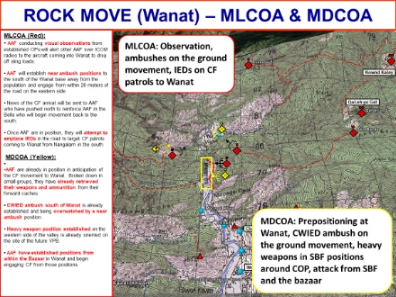
Slide 37. ROCK MOVE (Wanat) – MLCOA & MDCOA

  - Intelligence Preparation of the Battlefield (IPB) for CONOP ROCK MOVE.

    - TF Rock took into consideration everything they understood about insurgent attacks in their AO for ROCK MOVE.
      - Based on their experiences, the most likely course of action for the insurgents (called a MLCOA) was continuing their usual pattern of attacks:
        - Gradual escalation of activity – placement of OPs around Wanat, and IEDs on the road from FOB Blessing.
        - Move major weapons into position and “dial in” the proper range for rockets and mortars.
        - Harassment fire from all directions and then a large scale attack after about 90 days.
      - The most dangerous course of action (called a MDCOA), however, was an attack on the helicopters moving men and supplies, or a large scale attack on the COP in the early days of its construction – while the defenses and fighting positions were unfinished or unimproved.

    - This belief about the MLCOA and MDCOA was shared not just by the staff in TF Rock, but also the staffs in TF Bayonet and CJTF-101.

  - Securing ROCK MOVE.

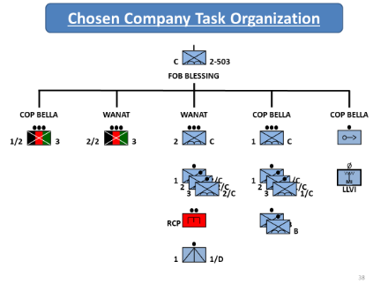
Slide 38. Chosen Company Task Organization

    - Task Organization.
      - 2nd Platoon was provided a six-soldier engineer squad with a Bobcat front end loader to help fill HESCO barriers and make other position improvements. A civilian construction company had been contracted for facilities, buildings, and other force protection measures.
      - A 120mm and a 60mm mortar was allocated for Wanat to provide internal fire support, like what had been provided at COP Bella.
      - A TOW missile section from Destined Company provided responsive and highly accurate direct fire against distant targets. Insurgents particularly hated the TOW for its effectiveness, calling it the “Finger of God”.
      - A 24-man ANA platoon with its 3 embedded Marine trainers was attached, armed with AK-47s and RPGs. The Marines brought an additional M240 machine gun with them.

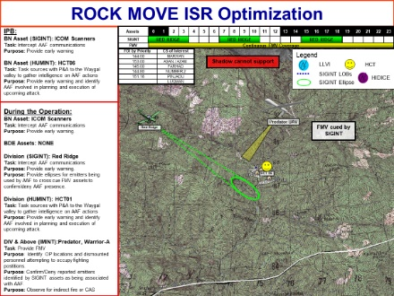
Slide 39. ROCK MOVE ISR Optimization

    - Intelligence, Surveillance, and Reconnaissance (ISR) Support. Organic and external ISR resources were allocated to support the security of ROCK MOVE.
      - One of TF Rock’s two Long Range Advanced Scout Surveillance Systems (LRAS3) was provided to 2nd Platoon. It provides powerful night vision and long range visual observation capabilities.
      - The TOW missile section’s Improved Target Acquisition System (ITAS) provides much the same capability as the LRAS3.
      - TF Rock requested 24-hour Full Motion Video (FMV) coverage for nine days starting 8 July. CJTF-101 was able to provide (but not guarantee) 24-hour coverage for the first 72 hours with one of its two Unmanned Aerial Vehicles (UAVs), an RQ-1 Predator or its armed version, the MQ-1 Warrior Alpha.
      - CJTF-101 also assisted with TF Rock’s request for 12 hours of SIGINT coverage per day for nine days. A theater-level system called Red Ridge was tasked on behalf of CJTF-101 for the requested coverage times, but again only for the first 72 hours.
      - TF Rock’s internal or attached SIGINT systems, paired with the Red Ridge coverage, could eavesdrop on insurgent communications and provide advanced warning of an attack. The FMV capability, when cued by a SIGINT intercept, could be directed to a specific location for positive identification and gathering more information.

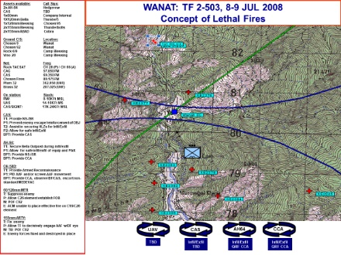
Slide 40. WANAT: TF 2-503, 8-9 JUL 2008 Concept of Lethal Fires

    - Fire Support.
      - In addition to the 120mm and 60mm mortar provided to 2nd Platoon, they had Priority of Fires from the two 155mm howitzers at FOB Blessing. The cannon tubes would be aimed their direction continuously and 2nd Platoon’s calls for fire would be executed first.
      - The AH-64s on ground alert at Jalalabad could respond and be on station over Wanat in 30 minutes if called, and if not available TF Out Front could divert Apaches on other missions to support them.
      - In total, the strength of the force at the outpost would be 44 US Soldiers, three US Marines, and 24 Afghan soldiers. Seventy-one people were available for the initial establishment of the base. Seventy-five were planned to regularly man the garrison.

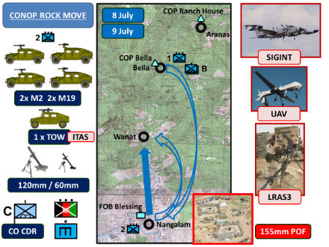
Slide 41. CONOP ROCK MOVE

  - Executing ROCK MOVE 8-9 July.

    - Two squads from Battle Company were attached to 1st Platoon at Bella for additional security before ROCK MOVE began.

    - (41-1) 8 July – the first of two simultaneous moves in the hours of darkness.
      - Two CH-47s escorted by two AH-64s from TF Out Front lifted 1st Platoon’s equipment from Bella to Blessing.
      - 2nd Platoon’s personnel executed their mounted ground movement in armored HMMWVs with crew served weapons (two M2 machine guns and two Mk19 grenade launchers).

    - (41-2) 9 July – the second of two simultaneous moves.
      - In daylight hours, the CH-47s delivered 2nd Platoon’ equipment, the engineers and their equipment, a 120mm mortar, some of the ANA platoon, and barrier materials from Blessing to Wanat.
      - At night, the CH-47s lifted 1st Platoon’s personnel from Bella to Blessing. The remainder of the ANA platoon and some 120mm ammunition are delivered to Wanat on the way to Blessing.

    - ROCK MOVE was executed on schedule without incident.

Follow the Waygal Valley left (south) from OP Speedbump to Wanat. Match the virtual views below with the visuals as much as possible. Point out the major terrain features in and around Wanat.

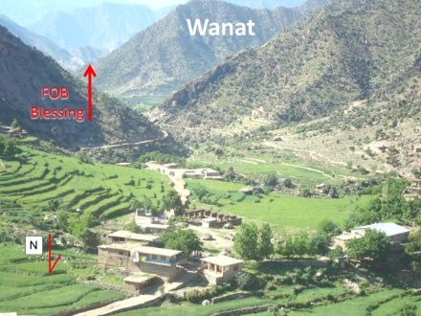
Slide 42.

Virtual View 13. Wanat From the North

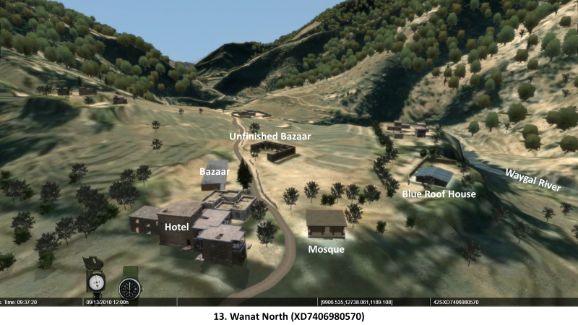

Move to the left (east) and view Wanat from the east.

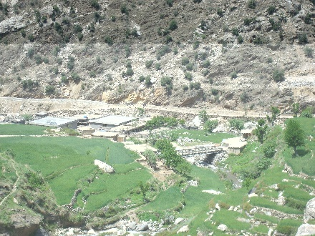
Slide 43.

Virtual View 14. Wanat East

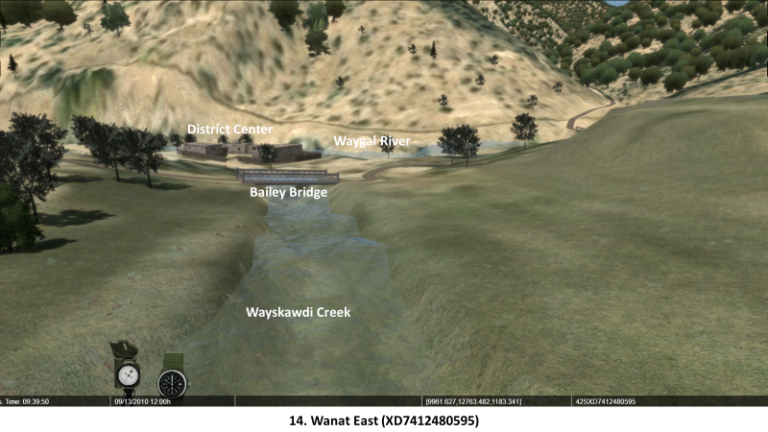

Move across the Waygal River to the west side of the valley and view Wanat from the west.

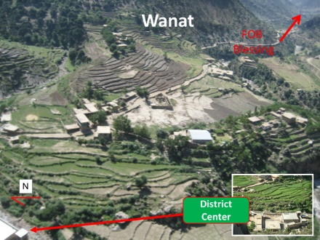
Slide 44.

Virtual View 15. Wanat West

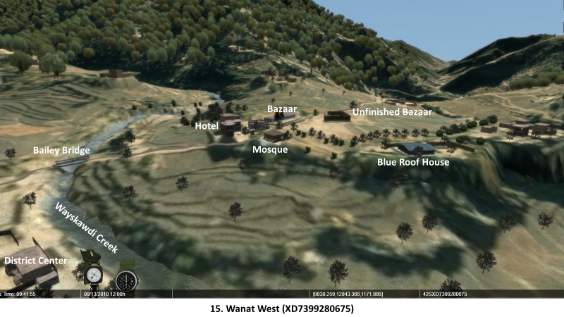

Move to the right (south) and view Wanat from the south.

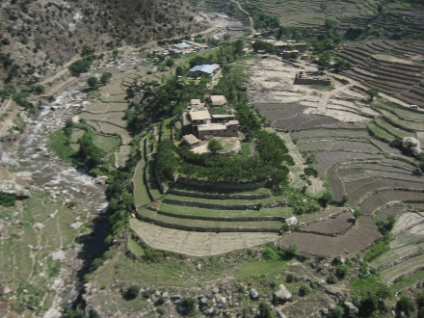
Slide 45.

Virtual View 16. Wanat South

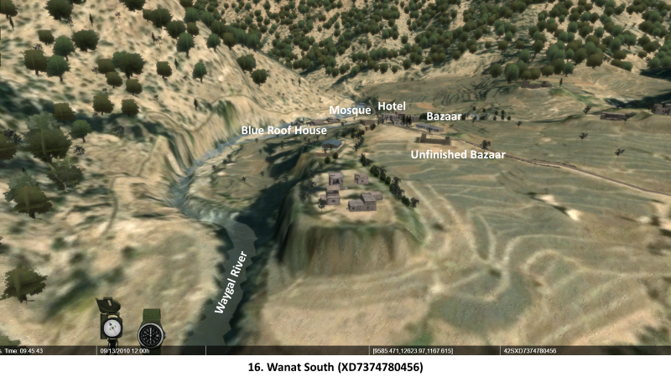

- First Look at Wanat. Visible are the major natural and man-made terrain features of Wanat:

  - Waygal River. Flows in a deep gully on the west side of town.

  - Bridges built by 1-32 IN. The people of Wanat protected the engineers who built these bridges.

  - Wayskawdi Creek flowing into the Waygal River. Also flows in a deep ravine on the north side of town.

  - District Center and ANP District Headquarters. New buildings constructed by the Coalition.

  - Mosque.

  - Hotel. Used by travelers moving up and down the Waygal Valley.

  - Bazaar.

  - Unfinished Bazaar. Next to the temporary base the engineers used while they were building the bridges.

  - Residences. The one with the metal roof is known as the “Blue Roof House”.

  - Rock-walled terraces for agriculture. The rock walls are generally chest-high or lower and easy to climb.

  - Road south to Nangalam and FOB Blessing.

ANALYSIS.

- What was different about 2-503 IN’s experiences in the Waygal Valley from those of 1-32 IN? What influences might have been responsible for those differences? What does this say about the challenges of conducting a counter-insurgency?

- Based on the video, was the evacuation of COP Bella an “IO win” for the insurgents? What factors were bearing on TF Bayonet’s and TF Rock’s decision? Are there other factors they might have considered that might have altered their decision?

- Was CONOP ROCK MOVE a suitable, feasible, and/or acceptable course of action? Why or why not? What alternatives might there have been?

- Was it unreasonable to expect and plan for the most likely enemy course of action after almost 15 months of a deployment, when doctrine recommends planning for the most dangerous? Why expect your enemy to behave any differently, and what indicators might point towards a change? How do you find those indicators?

- What challenges, both internal and external, will 2nd Platoon face establishing a COP in Wanat?

Place the participants on a break and have the terrain tech switch to the Company terrain database.

Stand 3: Occupation of COP Kahler

Visuals | Virtual Views
47. (Untitled) | 17. COP Kahler
48. 2nd Platoon Occupies Wanat
49. COP Kahler Fighting Positions | 18. 1st Squad/TCP
 | 19. 2nd Squad/ECP
 | 20. 3rd Squad/ANA Platoon
 | 21. Mortar Section
 | 22. CP
 | 23. TOW Section
50. OP Topside | 24. OP Topside
 | 25. Northern Position
 | 26. Crow’s Nest
 | 27. Southern Position
51.Planned Observation Posts

ORIENTATION. Show the overhead view of COP Kahler.

Virtual View 17. COP Kahler

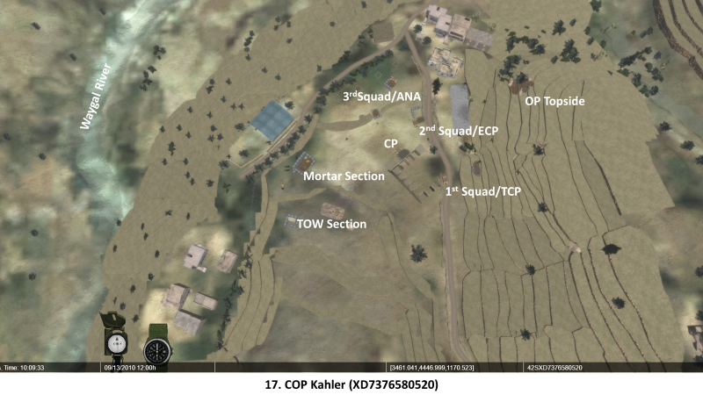

DESCRIPTION.

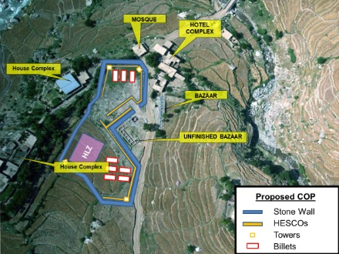
Slide 47. (Untitled)

- COP Kahler.

  - The construction of COP Kahler was expected to take about eight weeks once the contractors started work.

    - COP Kahler was about 165 meters long north to south.

    - About 50 meters wide east to west at its widest point.

    - The distance from the COP to the OP was about 60 meters.

    - When complete, COP Kahler would be surrounded by seven-foot stone walls and triple-strand concertina wire. The facility would also include guard towers, hardened barracks, showers, and a latrine.

- Delays Create Challenges for Construction.

  - The contract for COP Kahler’s construction went to a firm in Jalalabad for heavy equipment and operators. They would provide the earth fill service for the HESCO barriers and lay out a gravel surface inside the walls.

  - When ROCK MOVE’s start date was changed to 8 July, the company returned its prepositioned equipment at Asadabad to Jalalabad, and was unable to regroup it before 13 July.

  - The bulk of the initial defensive work fell to 2nd Platoon and the engineer squad.

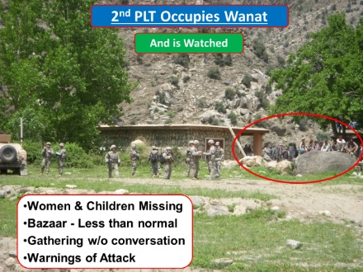
Slide 48. 2nd Platoon Occupies Wanat

- Occupation of COP Kahler.

  - The night of 8 July, the first contingent of 2nd Platoon occupied the same site used by 1-32 IN’s engineers the year before when they constructed the bridges.

    - The first morning they were there, they swept the site for mines and IEDs.

    - 1LT Brostrom and SGT Ryan Pitts, the platoon’s Forward Observer (FO), started looking for an OP site on the ridge to the east.

  - On 9 July, the remainder of 2nd Platoon arrived by CH-47, followed by the ANA platoon with its ETTs, the engineer squad, the 120mm mortar, and ammunition, supplies, and barrier materials.

  - While the defenses and the OP were being constructed, many of 2nd Platoon’s soldiers picked up indicators of the enemy’s presence.

    - (48-1) Wanat is a village of about 50 families, but the women and children were absent.

    - (48-2) There was less-than-normal activity in the bazaar.

    - (48-3) Men gathered without conversing – they just watched the Americans for long periods of time. Normally, Afghan men can have animated conversations for many hours at a time.

    - (48-4) Braver individuals gave warnings of an impending attack, but this was not unusual and happened often without an attack occurring.

SFC David Dzwik, who had replaced SFC Kahler as Platoon Sergeant, on being told they would be attacked:

Up until the night of the 12th, we, of course, were being told that we were going to be attacked, and it’s not that we were taking that lightly; we always know that there was a really, really good possibility of it. But everywhere we went and every day I was in-country, a different person would tell me that.

- Establishing the COP, OP, and Morale.

  - The engineers surveyed and marked off the positions of the eventual guard towers and walls for when the civilian contractors arrived, and filled HESCO barriers with the Bobcat. Later the pump on the fuel blivet broke down, and made the Bobcat unusable when it ran out of fuel until the pump was replaced.

  - The fighting positions were a mix of sandbags, vehicles, HESCO barriers, and other material. Lack of available construction material did not allow for overhead cover.

  - The soil was hard with lots of rocks that made digging difficult with the limited hand tools and entrenching tools in the platoon.

  - Hot weather hindered the platoon’s efforts at constructing its defenses, sometimes rising to over 100°F.

    - Working or providing security in such temperatures increased water consumption.

    - On the first day, Dzwik quickly realized that the platoon would need more water and coordinated for a resupply, and limited the hardest labor to cooler periods of the day to conserve it.

    - By the 11th, though, water was no longer an issue.

  - Brostrom and Dzwik carefully ensured that all weapons and supplementary weapons systems were positioned in overlapping fields of fire with formal range cards, and a perimeter sketch (similar to that used at Ranch House) was in the CP.

  - Despite Brostrom’s attempts to interact with the villagers, he was unable to coordinate any shuras and 2nd Platoon’s interactions with the population was minimal. Interactions with the ANA platoon were also limited while the defenses were constructed.

  - 2nd Platoon was less than two weeks from redeployment and on a short timeline to establish a COP in Wanat. Most of their personal items had been shipped back to Italy, and they lived out of what they carried in their rucksacks.

Show the video made by SPC Riley Stafford showing the construction of OP Topside.

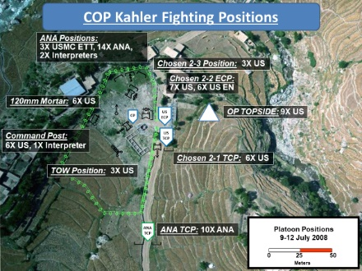
Slide 49. COP Kahler Fighting Positions

- COP Kahler Positions. By the night of the 12th, 2nd Platoon had made good progress constructing their defenses while they waited for the Afghan contractors and their 1-26 IN replacements to arrive.

  - (49-1) A perimeter of double-strand concertina wire surrounded the COP. Driving pickets and laying concertina wire is manpower-intense and hard labor; only two complete perimeter strands in that amount of time is not unusual.

  - (49-2) ANA Traffic Control Point (TCP) – ten ANA soldiers manned this first position.

Move from position to position as shown in the virtual views that follow. But instructors are free to move around each position to examine specific features such as fields of fire and observation.

Virtual View 18. 1st Squad/TCP

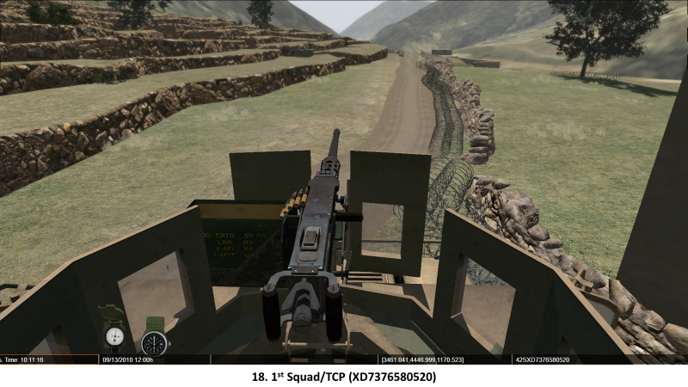

  - (49-3) US TCP – 1st Squad with six paratroopers under SSG Hissong manned this second position, just north of and covering the ANA TCP.

Move to 2nd Squad’s position. Look left at the bazaar. The Mk19’s actual field of fire was centered here.

Virtual View 19. 2nd Squad/ECP

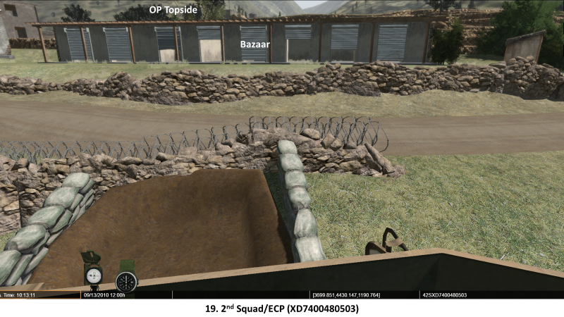

  - (49-4) US Entry Control Point (ECP) – 2nd Squad manned this position with seven paratroopers. The engineer squad also occupied this position when it wasn’t at work on the defenses.

Move to 3rd Squad’s position to discuss the ANA Platoon and 3rd Squad.

Virtual View 20. 3rd Squad/ANA Platoon

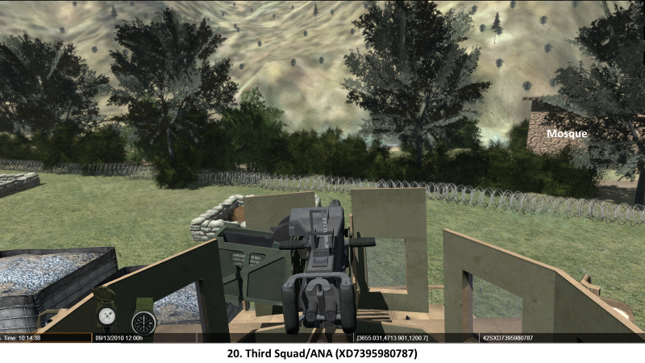

  - (49-5) ANA Platoon – on the north side of the COP perimeter was the rest of the ANA platoon: 14 Afghans and their three Marine ETTs.

  - (49-6) 3rd Squad – three paratroopers from 3rd squad occupied a supporting position behind the ANA platoon.

Lift up and look at the dead space beyond the trees in the river valley below. Then move to the mortar position.

Virtual View 21. Mortar Section

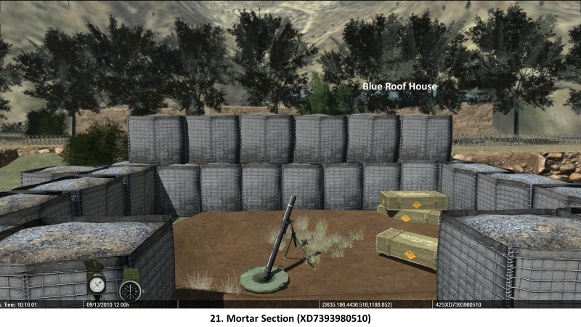

  - (49-7) Mortar Section. Six mortarmen attached to 2nd Platoon served the 120mm mortar protected by the HESCO barriers, and the 60mm mortar (protected by a few sandbags) positioned near the center of the COP near the CP.

Move to the CP.

Virtual View 22. CP

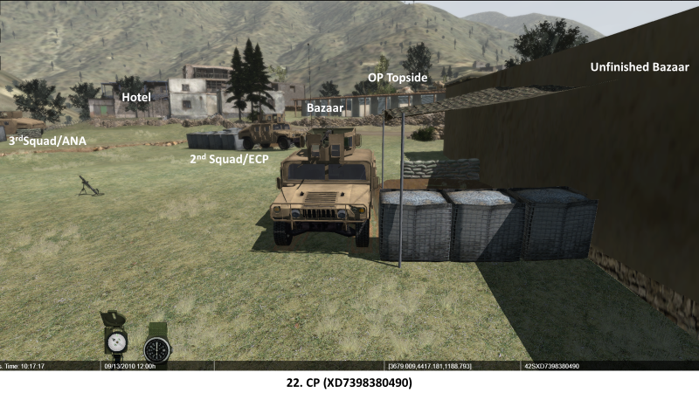

  - (49-8) Command Post. The company commander, platoon leader, platoon sergeant, and three paratroopers worked out of the space between the command HMMWV and the wall of the unfinished bazaar.

Move to the TOW Section position.

Virtual View 23. TOW Section

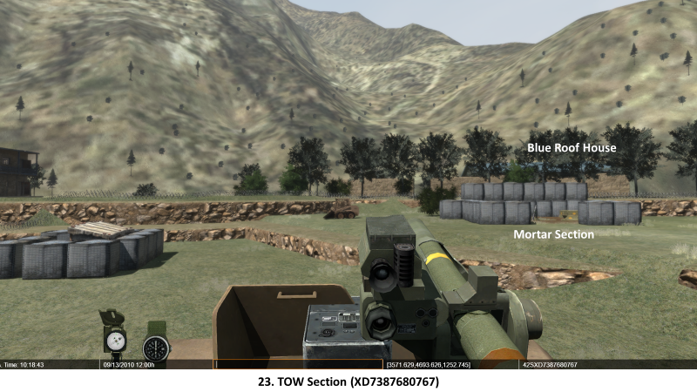

  - (49-9) TOW Section. Three TOW crewmen and their weapon system overwatched the southern portion of the COP and the mountain slopes to the west.

Move to the overhead view of OP Topside.

Virtual View 24. OP Topside

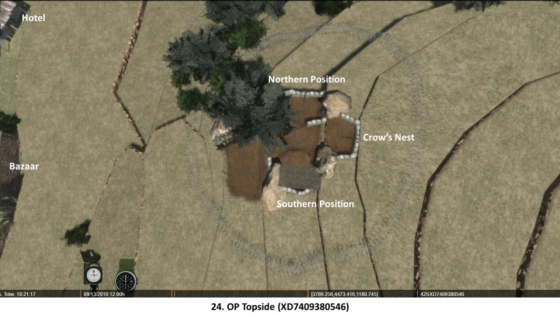
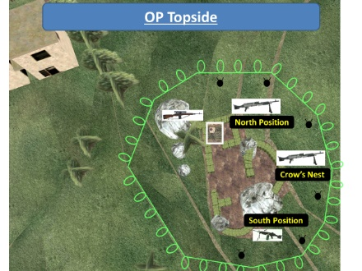
Slide 50. OP Topside.

  - OP Topside.

    - SGT Pitts, the FO, and eight paratroopers were located here, about 60 meters from the main COP on a knoll behind the old bazaar.

    - It had three connected fighting positions, anchored on natural cover provided by a few large boulders, and fenced with a single strand of concertina wire.

Descend into the northern position.

Virtual View 25. Northern Position

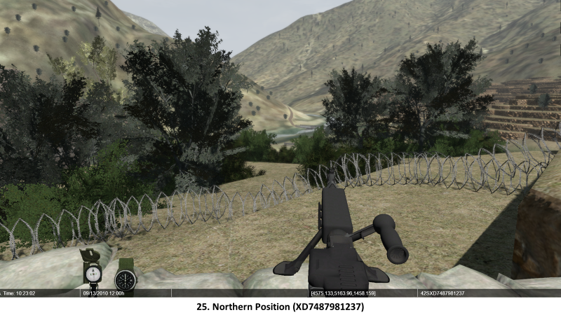

    - (50-1) The northern position was roughly square and faced the north and northeast. It was anchored on one of the boulders and contained an M240 machine gun.
      - The platoon’s Designated Marksman and his rifle was placed near the boulder.
      - The FO also placed the LRAS3 here with his radio.
      - Two claymore mines are placed outside the position to fire down into the dead space to the north and east.

Back out of the northern position and turn right (east) into the crow’s nest.

Virtual View 26. Crow’s Nest

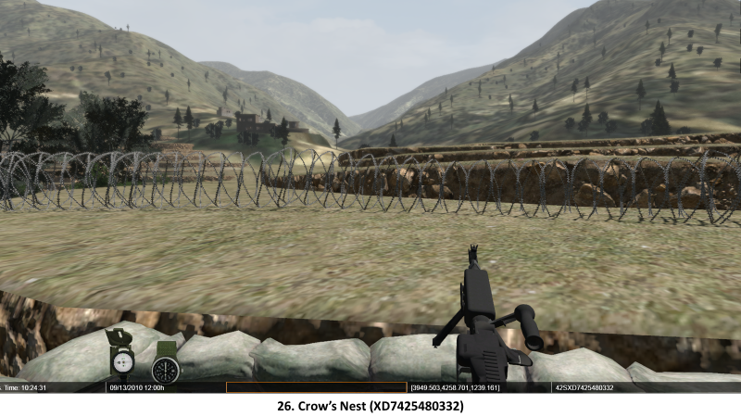

    - (50-2) The “crow’s nest” was a semi-circular position in the center oriented to the east.
      - It also contained an M240 machine gun.
      - It was on the terrace above the other fighting positions, and also had claymore mines covering dead space to the east.

Back out of the Crow’s Nest and turn left (south) into the southern position.

Virtual View 27. Southern Position

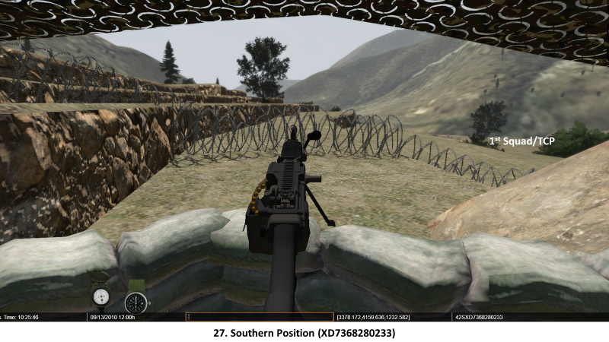

    - (50-3) The southern fighting position was roughly square and faced the south and southeast, and was called the “Alamo” by the soldiers in OP Topside. It had an M249 Squad Automatic Weapon (SAW), an M203 40mm grenade launcher, and controlled two more claymores oriented into the dead space on the south and east.

    - OP Topside also contained one Vietnam-era M72 66mm Light Anti-Armor Assault Weapon (LAAW) and a large quantity of hand grenades. SGT Pitts could control fires on his planned targets with artillery or mortars from here.

SFC Dzwik had this to say about OP Topside:

I didn’t like the OP but it was the best spot we had available. I felt that to the east the enemy had too much cover and concealment to move up on it, but we didn’t want to move the OP too far where it would be too far away to easily reinforce and support, yet we wanted a good position.

SGT Pitts said much the same:

I agreed with the platoon leader when he said he didn’t want the observation post to be too far out, because we didn’t really have a lot of people and where we were just building our fortifications wasn’t going to be that great. We were doing everything by hand ourselves in just a couple of days.

I agreed that we couldn’t kick it out too far. We’d talked about moving it to an abandoned house but that was still too far. We needed it to be close because we simply didn’t have enough guys. We were a platoon doing a company mission. We couldn’t put it in the village and we couldn’t take the hotel. It was the only semi-elevated place with some cover. We wanted to have something out there so we just went with it.

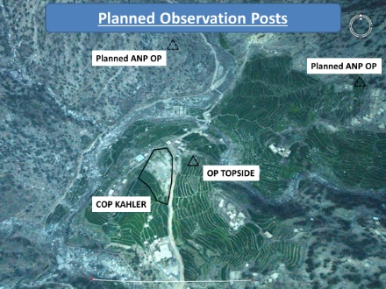
Slide 51. Planned Observation Posts

  - Planned Positions/Position Improvement.

    - An ANA OP was planned for the eastern ridge south of Wanat overlooking the road from Nangalam/FOB Blessing (not visible on the slide.)

    - Two ANP OPs were planned for the ridges on each side of the Waygal River, on the crest north of the bridge and up on the slope for good observation.

    - In addition to 23 planned Indirect Fire Targets established to support ROCK MOVE, SGT Pitts submitted a supplementary list of 13 planned targets on 10 July for COP Kahler’s defensive plan.

ANALYSIS.

Instructor’s Note: Analysis of the COP Kahler positions can be done with the DESCRIBE portion of the stand to save time, or can be done separately as written here.

- Using the OACOK (Observation/Fields of Fire, Avenues of Approach, Cover and Concealment, Obstacles, Key Terrain) method of terrain analysis, what were the advantages and disadvantages of each fighting position in COP Kahler?

- What is your impression of 2nd Platoon’s morale after viewing SPC Stafford’s video of OP Topside as they built it? Were the fighting positions constructed poorly or were they well-built for the time, tools, and materials available to them? Which says more about morale: the quality of their work or what they say to each other about their situation?

Stand 4: Enemy View of COP Kahler

Visuals | Virtual Views
53. (Untitled) | 28. COP Kahler
 | 29. Waygal River Enemy Avenue of Approach
 | 30. Blue Roof House Enemy Position
 | 31. Wayskawdi Creek Enemy Avenue of Approach
 | 32. Enemy Avenue of Approach to OP Topside

ORIENTATION. Show the overhead view of COP Kahler.

Virtual View 28. COP Kahler

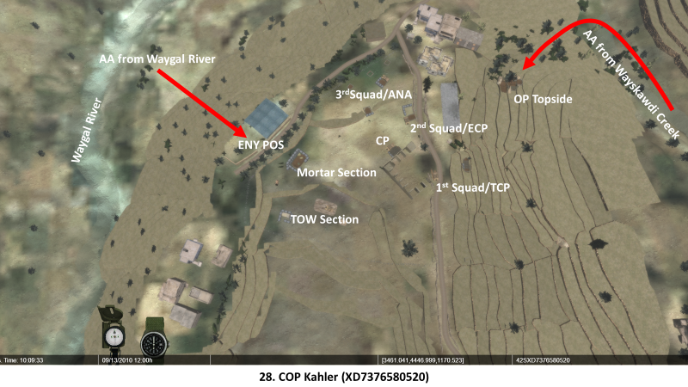

DESCRIPTION.

- Insurgents in the Waygal Valley.

  - The key insurgent leader in the Waygal District was Mullah Osman, a Nuristani from the northern Waygal Valley village of Waygal.

    - Though not a formal member of any specific group, he worked with a wide range of insurgent elements in Nuristan and Kunar provinces.

    - Osman used intimidation and force to retain influence over the local leaders in the Waygal Valley.

    - TF Rock assessed he controlled 130 to 150 experienced fighters around Bella and Wanat. He was also able to bring insurgent groups from the Korengal and Watapur valleys to launch larger attacks on Coalition forces.

    - SIGINT confirmed he was wounded in the 4 July Apache strike at Bella. Leadership of his operations shifted to a younger local insurgent leader.

  - Mawlawi Sadiq Manibullah identified himself as the leader of the attack on Wanat in a video released some months afterward.

    - Mawlawi was the son of an Aranas elder with previous ties to the insurgent group Hizb-i-Islami Gulbuddin (HiG) and was influential in Wanat.

    - It is likely that Mawlawi led the 13 July attack on COP Kahler.

  - Insurgent Profiles. Insurgents in Afghanistan can generally be described in a few ways: local fighters, dedicated core fighters of a group such as HiG, organized criminal factions that are Afghan-centric, and hardcore Islamic fundamentalists like the Taliban or Al-Qaeda that are considered transnational.

    - Local fighters are generally young, unemployed, and poorly educated.
      - They are used as laborers or have rudimentary weapons training.
      - They are not generally ideologically motivated and can be swayed from other insurgents with regular employment or economic opportunities.

    - Core fighters are motivated by ideology, and criminal factions by significant economic or financial interests.
      - Both are generally experienced, highly skilled, well trained, and well equipped.
      - Their predominant focus is on their immediate home community, district, or province.

    - The hardcore fundamentalists are often foreign fighters who operate across international borders.
      - They come from a variety of countries and are totally dedicated to their cause and unwilling to compromise.
      - They generally have considerable financial and material resources with which to influence both local and core fighters.

- COP Kahler’s Effect on the Insurgency.

  - From an insurgent’s perspective, COPs represent several threats:

    - The Coalition uses them to launch regular patrols and interact with the local population, degrading insurgent ability to interact with the population.

    - Second, once the base is established, any insurgent attack might engender hostility from the adjacent community, risking alienation from the insurgent cause.

    - Third, it represents more than just the threat of a larger Coalition force providing greater security in the immediate area – it introduces jobs into the greater community that often hire local workers, providing the employment or economic opportunities that creates unwanted competition for local fighters.

  - COP Kahler represented all three of these threats to insurgents in the Waygal Valley.

- Insurgent Objectives. The actual insurgent objectives in the Attack on Wanat are not known, but had the potential to achieve effects at the tactical, operational, and even strategic level. It has been almost a year since the Ranch House attack, and they have had that entire time to plan the next one.

  - The tactical objective could have been a complete overrun of COP Kahler, but given the amount of firepower the Coalition can bring to bear in a short time, this is not as likely as an attack to produce the largest possible number of Coalition casualties.

  - The operational objective could have been to force a Coalition withdrawal from the Waygal Valley to increase freedom of insurgent movement in Nuristan Province and over the Afghanistan-Pakistan Border.

  - A successful attack could also support a strategic objective of showing the Coalition as unable to protect itself in the eyes of the international community. Afghans had done the same against the Soviets, and insurgent IO is sophisticated enough to do that.

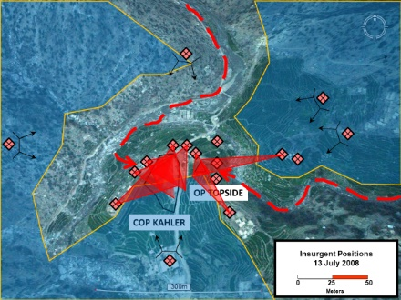
Slide 53. (Untitled)

- Insurgent Scheme of Maneuver.

  - (53-1) Support by fire positions for suppressive fire on COP Kahler are on the ridges beside the Waygal River north of the bridge, and on the mountain slope on the west side of the river.

Descend into the Waygal Valley at or near the positions shown in Virtual View 28. Match the view shown below.

Virtual View 29. Waygal River Enemy Avenue of Approach

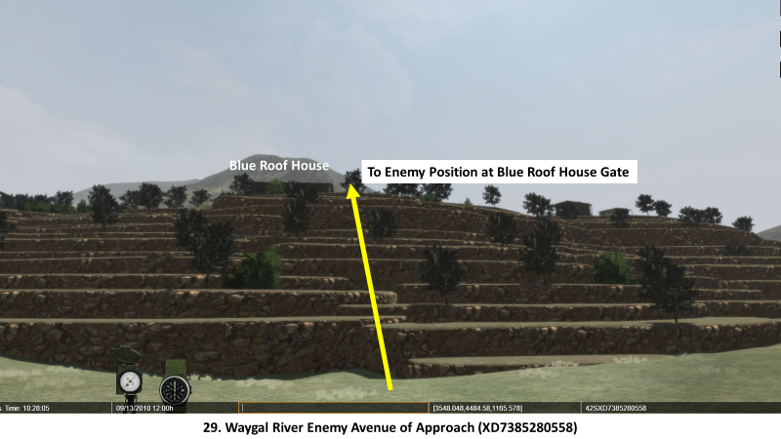

  - (53-2) The dead space in the Waygal Valley river bottom is a concealed avenue of approach, and the sound of movement is masked by the sound of the river. It is used to infiltrate into attack positions in the buildings on the west and north side of COP Kahler.

Follow the yellow arrow as indicated in the virtual view until you reach the opening in the wall around the Blue Roof House.

Virtual View 30. Blue Roof House Enemy Position

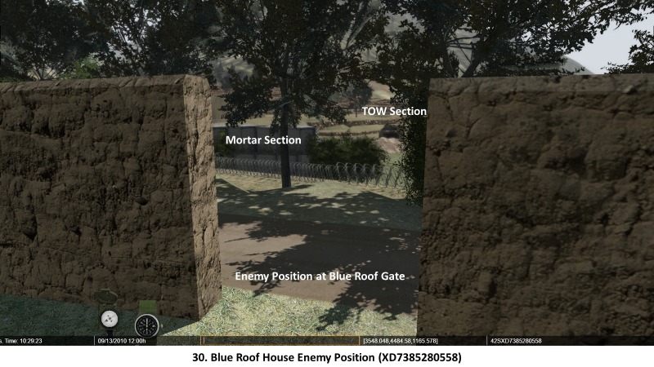

    - A 7.62mm PKM general-purpose machine gun is emplaced on or in one of the buildings in this compound.

    - Looking through the gap in this wall is another attack position.

    - This position on or in the Blue Roof house has an RPG team. It will fire on the mortar pit and TOW section.

    - The mosque is used as an attack position.

    - Attack positions in the two-story hotel complex will fire on both COP Kahler and OP Topside. It is possible that a DsHK 12.7mm heavy machine gun was placed there.

    - These positions have interlocking fields of fire that dominate every position in COP Kahler.

Lift up from the Blue Roof House, fly over COP Kahler and OP Topside and take up a position at or near the one shown in Virtual View 31. Match the view shown below.

Virtual View 31. Wayskawdi Creek Enemy Avenue of Approach

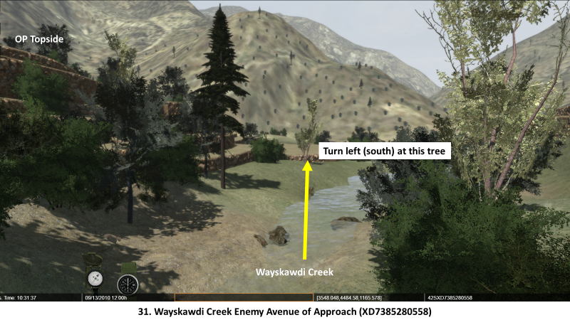

  - (53-3) The dead space in Wayskawdi Creek and the ridge to the south of it are also concealed avenues of approach for SBF and Attack Positions to the northeast and east of OP Topside.

Walk forward to the tree as indicated in the virtual view above and turn left (south). Match the view shown below.

  - There are SBF positions in the village of Qalah-ye Gah across Wayskawdi Creek to the northwest and farther up the mountain slope behind it.

Virtual View 32. Enemy Avenue of Approach to OP Topside

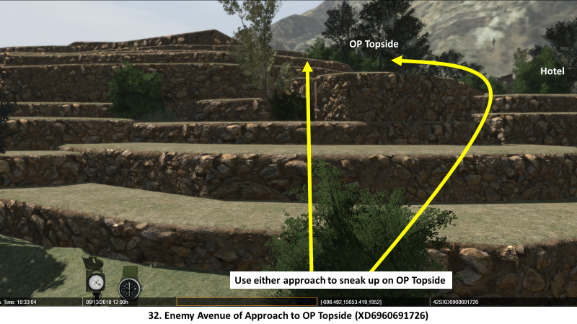

  - The attack positions for OP Topside are here. Note how close insurgents can approach before they are visible to the defenders.

Follow either yellow arrow and “sneak up” on OP Topside. Ask the participants to stop your movement when they think they see OP Topside. After you stop, lift in altitude to emphasize how close you can get to Topside without being seen.

  - These positions also have interlocking fields of fire that dominate every position in OP Topside.

- Coalition Intelligence, 8-12 July. TF Rock had requested 24 hours of UAV FMV coverage and 12 hours of SIGINT coverage for the first three days of the operation, and received those allocations from RC-East and Theater assets, but reaction to insurgent activities in other areas reduced the actual hours TF Rock received.

  - On 8 July the SIGINT coverage was unaffected, but the UAV FMV coverage was reduced to 16.5 hours. The same amount of coverage from both systems was received on 9 July.

  - On 10 July, response to enemy activity reduced SIGINT coverage to 7.5 hours and UAV FMV coverage to 13 hours.

  - Despite these reductions, TF Rock was satisfied with the ISR support for ROCK MOVE and those systems did not detect any indications of many insurgents gathering around Wanat in the period between 8 and 10 July. The lack of indicators further reduced the SIGINT and UAV allocations on 11 July despite protests from TF Rock, and weather effects reduced it even more on 12 July.

  - At night, the sentries in 2nd Platoon did not see or hear anything suspicious between 8 and 12 July. They were alert and active; one even reported the 14 shooting stars he saw in the early morning hours.

  - Despite the warnings of an attack and the apprehensions of the soldiers, none of what they observed in Wanat since their arrival was considered out of the ordinary.

ANALYSIS.

- Compare 2nd Platoon’s and the Insurgents’ consideration of the Mission Variables Terrain, Troops, Time, and Civil Considerations (Human Terrain). Who is using them to their advantage? Who is at a disadvantage, and how might you minimize those disadvantages?

- How might the insurgents have kept the ISR assets from detecting their movements and communications? Were they effective?

- Does the insurgent scheme of maneuver more closely resemble the MLCOA or the MDCOA? Which of those has TF Rock prepared for?

- Could earlier coordination with the ANP have gotten them to establish their planned OPs?

Stand 5: The Attack on COP Kahler, 13 July

Visuals | Virtual Views
55. Final Events Prior to Attack – 12 July | 33. COP Kahler
56. 130345-0420 JUL | 34. CP
57. OP Topside 130420 JUL
58. 130423 JUL
59. OP Topside 130423 JUL
60. 130430 JUL
61. OP Topside 130430 JUL
62. 130430 JUL
63. OP Topside 130430 JUL
64. CAS, CCA, and MEDEVAC 130452 JUL
65. 130452 JUL
66. CAS, CCA, and MEDEVAC 130522 JUL
67. OP Topside 130523-0545 JUL
68. Planned Observation Posts and Enemy Locations

ORIENTATION. Show the overhead view of COP Kahler.

Virtual View 33. COP Kahler

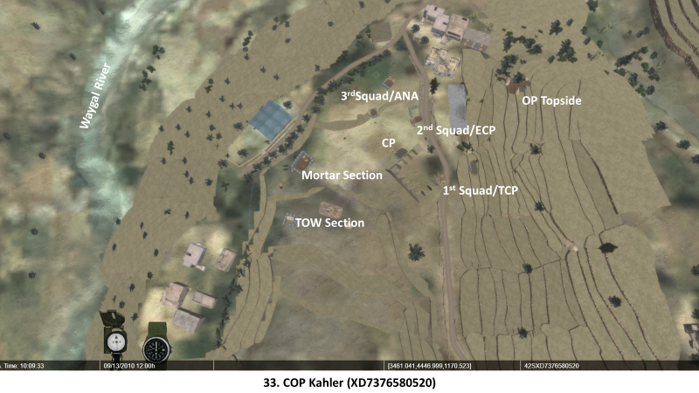

DESCRIPTION.

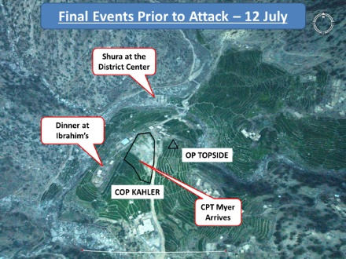
Slide 55. Final Events Prior to Attack – 12 July

- 12 July: The Day before the Attack.

  - (55-1) 1LT Brostrom had been trying meet with village elders and the ANP since 9 July, but without success.

    - On 12 July, he heard that a shura was being held in the District Center.

    - Brostrom was upset because he was not invited.
      - Brostrom quickly assembled SSG Benton, the ANA platoon leader, an interpreter, five soldiers and an ANA squad and rushed over to the District Center.
      - They got a cold and culturally improper reception.

SSG Benton remembered his impression of what happened. “The reception was not warm at all. The ANP did not respond to any of our greetings and seemed very nervous that we were there.”

    - When Brostrom and his party returned to the COP, he immediately reported the shura and how he was received to the TF Rock Operations Center. It grabbed the attention of TF Rock’s Intelligence Officers.

  - (55-2) Shortly after Brostrom’s return from the shura, CPT Myer arrived on a helicopter with a resupply of water, rations, and a replacement pump for the Bobcat’s fuel blivet.

    - Brostrom briefed Myer on the defensive arrangements and the fire support plan.
      - Then they inspected the defenses.
      - Myer was not enthusiastic about the location of OP Topside.
      - After some discussion with his men, though, he decided to delay relocating it.

Myer recalled his impression of OP Topside: “I suggested moving it higher on the hill but all the paratroopers and the [platoon] leader said it would be more exposed on the hilltop and they would rather have the force protection of the rocks. I agreed we would move it when we had more force protection.”

    - While they were inspecting the positions, Myer speaks with Ibrahim, a known Coalition supporter who invited him to dinner – but after dark.

  - (55-3) Myer and Brostrom went to Ibrahim’s house after dark for the meal. One other village elder was there, and Ibrahim warned them that “if they saw any people up in the hills, we should shoot at them because they’re bad…there were bad people around.”

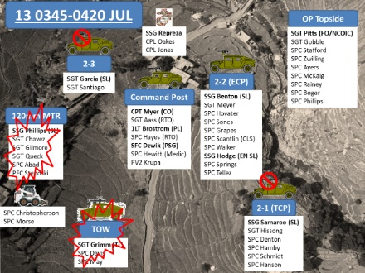
Slide 56. 130345-0420 JUL

- 13 July: Stand-To.
  - Every morning, every soldier in COP Kahler is awake and in their fighting positions between 0345 and 0350, a practice called “Stand-To”.

    - Weapons are loaded and oriented on their primary fields of fire.

    - Soldiers are wearing their Personal Protective Equipment (PPE).

    - The ANA platoon and their ETTs also participate in Stand-To.

    - The only soldier who is not in his assigned fighting position is PV2 Krupa from 3rd Squad, who is manning the CP’s M2 machine gun.

    - COP Kahler and OP Topside are fully alert and ready for action, inspected by SFC Dzwik.

  - 1LT Brostrom is organizing his US/ANA patrol to locate the site for the ANA OP. It is scheduled to depart at 0430.

  - Two engineers are at work with the Bobcat and excavating a ditch to divert water from the mortar position. A natural spring had opened up that night, pouring water into it.

  - The TOW section reports visual contact with 7-10 males moving on the hillside south of the 1st Squad TCP through their ITAS. They cannot not confirm if they are armed.

    - 0408: The TOW section reports visual contact with 5 males with backpacks on the western hillside opposite COP Kahler. They report their observation to CPT Myer.

    - Myer issues orders to engage them with the TOW and the 120mm mortar.

CPT Myer: “Five shepherds aren’t going to be together. Based on the terrorist videos that we’ve seen and things like that, a group of five to ten guys in the mountains is commonly enemy personnel.”

    - The TOW section tracks the target and prepares to fire a missile.

    - SGT Pitts, the FO in OP Topside, uses the LRAS3 to confirm the target’s coordinates for the 120mm mortar.

    - The 120mm mortar crew lays on Pitts’ target.

    - Twelve minutes pass between target identification, acquisition, and preparation to fire.

At 1st Squad’s TCP, SGT Brian Hissong tells SSG Samaroo: “We better [expletive] kill these guys before we get hit.”

    - SSG Samaroo’s reply is interrupted by two bursts of fire from a 7.62mm RPD machine gun, and then “about a thousand RPGs all at once.”

- The Attack on COP Kahler.

  - 0420: Insurgents start the attack with two bursts of fire from an RPD machine gun, then many RPGs and a continuous high volume of fire from positions around COP Kahler. Crew served weapons positions receive focused, concentrated fire: the TOW section, M2 machine guns and Mk19 grenade launchers on the HMMWVs, the mortar position, and OP Topside.

Descend into the CP or hover just above it. Look at the TOW section.

    - (56-1) A cross-fire of 3 RPG rounds strike the TOW section HMMWV, disabling it and setting it on fire. None of the crew is injured by the impacts.

Rotate right and look at the Mortar section.

    - (56-2) Insurgents in adjacent buildings and in the trees next to the COP suppress the mortar position, but the mortarmen still manage to fire 4 high-explosive rounds at the target on the western hillside before they are forced to defend themselves with individual weapons and hand grenades.
      - The two engineers in the Bobcat abandon it and dive for cover in the mortar pit, as does SFC Dzwik who is inspecting positions during Stand-To.

Rotate right and look at the 60mm mortar.

      - SSG Phillips, PFC Stenoski, SGT Chavez and SGT Queck periodically try to reach the 60mm mortar and put that weapon into action, but enemy fire sweeping the COP interior prevents them from employing it.
      - SPC Sergio Abad, one of the mortarmen, is wounded by RPG shrapnel in the legs and shoulders.

Rotate right and look at 3rd Squad’s position.

    - (56-3) At 3rd Squad’s position, the Mk19 is quickly disabled when a bullet strikes a hole in the feed tray, forcing the defenders to return fire with their M4s at the high cyclic rate of fire to make up for the loss of the crew served weapon.

Rotate right and look at 2nd Squad’s position.

    - At 2nd Squad’s position nearby, its Mk19 jams (which is a common malfunction) and continues to malfunction intermittently through the fight.

    - At the ANA position, the Marine ETT’s M240 machine gun is the remaining crew served weapon on that side of the COP to operate reliably, increasing its importance.

    - PV2 Krupa, manning the CP M2, returns fire exactly as he was trained to protect the growing number of men in the CP.

    - First Squad’s TCP does not escape the high volume of enemy fire.
      - SPC Hamby returns fire with a 100-round belt of .50 cal ammunition at an RPG firing point, but the volume of fire on the TCP increases.
      - When Hamby ducks down into the HMMWV for more ammunition, it is struck with concentrated RPG and small arms fire.
      - (56-4) When Hamby attempts to reload, a 7.62mm round strikes it directly on top of the raised feed tray cover and puts it out of action.
      - To neutralize the RPG firing point after losing the .50 cal machine gun, SGT Hissong fires an AT-4 rocket against it at the large compound on a prominent hill to the southeast of their position.

Rotate right and look at OP Topside just above the bazaar.

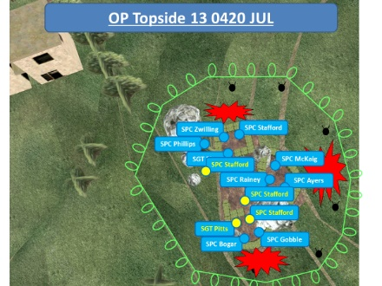
Slide 57. OP Topside 130420 JUL

    - In OP Topside, the first volley of RPGs kills, wounds, or stuns the nine soldiers in it.
      - (57-1) In the northern position manning the LRAS3, SPC Zwilling is killed; SGT Pitts and SPC Stafford are wounded.
        - Stafford is blown into the middle of the OP.
        - In the southern position, SPC Gobble is so badly wounded he can no longer defend the OP.
      - (57-2) Subsequent impacts toss Pitts into the Southern Position and Stafford onto the Sleeping Terrace. Shortly after Stafford is thrown onto the Sleeping Terrace, SPC Phillips (the platoon’s designated marksman) is killed by an RPG impact near his fighting position after throwing a hand grenade.
      - (57-3) After seeing Phillips get killed, Stafford crawls to the southern position and sees SPC Bogar defending it with his SAW. Bogar fires over 600 rounds at the cyclic rate of fire.

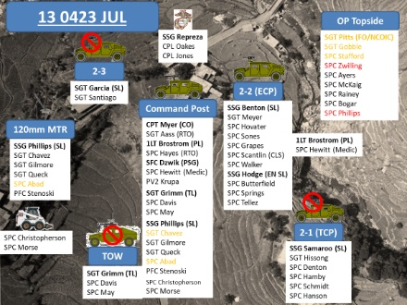
Slide 58. 130423 JUL

  - At or before 0423: CPT Myer reports heavy small arms and RPG fire focused on the TOW vehicle, mortar position, and OP Topside and requests fires from the 155mm howitzers at FOB Blessing. He describes the violence of the attack in unmistakable terms: “This is a Ranch House – style attack.”

    - Within one minute of Myer’s call for fire, the first of 96 155mm artillery shells are fired “Danger Close” at targets within 600 meters of COP Kahler. 2nd Platoon is responding to the attack with its own overwhelming volume of fire to gain control of the fight.

Rotate left and look at the TOW Section.

    - (58-1) The TOW vehicle continues to burn. SGT Grimm orders his two crewmen to evacuate it, and lays down covering fire to protect them before he makes his run to join them in the CP.

Rotate right and look at the Mortar section.

    - (58-2) The situation in the mortar position also deteriorates.
      - When an RPG explodes near the supply of mortar ammunition in a corner of the mortar pit, the containers begin to spark.
      - SSG Phillips realizes it must be evacuated and orders everyone to the CP.
      - They fire and maneuver across the exposed ground between the CP and mortar point.

    - SGT Chavez and engineer SPC Joshua Morse grab Abad and drag him to the CP through heavy enemy fire.
      - Chavez is wounded through both legs and collapses.
      - He continues to pull at Abad until other soldiers in the CP come out to drag both to safety.

    - The TOW section, just arrived at the CP, and other CP personnel provide medical treatment to the seriously wounded Abad and prepare the first MEDEVAC request.

Rotate right and observe the positions for 3rd Squad and 2nd Squad.

    - On the northern perimeter of COP Kahler, 3rd Squad, 2nd Squad, and the ANA continue to return fire against automatic weapons in the tree line and buildings beyond the wire.

Rotate right to observe 2nd Squad and OP Topside.

    - From the CP, 1LT Brostrom can see the RPGs detonate on OP Topside. Recognizing the OP had become the critical sector of the defense, and with CPT Myer present to run the fight from the CP, Brostrom feels his place is at OP Topside.

He tells CPT Myer: “We need to get up there.”

Myer replies: “OK, go ahead.”

    - (58-3) Brostrom grabs the platoon medic, PFC William Hewitt, and runs to the 2nd Squad position to gather a team for OP Topside.

Move from the CP into 2nd Squad’s position. Ensure you can still see OP Topside.

    - Shortly after that, the TOW vehicle explodes, scattering flames and smoldering TOW missiles in all directions.
      - The fireball severely burns one of the ANA soldiers.
      - It knocks out the Tactical Satellite (TACSAT) radio antenna and with it the backup means of communication.
      - Two unexpended missiles fall directly into the CP, one with the rocket motor running.
      - SSG Phillips grabs the hot missile with a pair of empty sandbags for gloves, and runs out of the CP under fire to drop it in the open area. He returns unhurt, and CPT Myer heaves the other missile over the CP’s sandbag wall.

Slide 59. OP Topside 130423 JUL
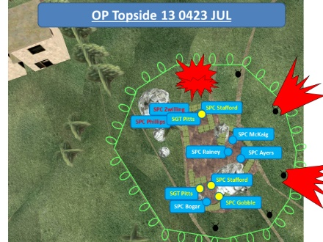
  - The situation in OP Topside becomes desperate.

    - In the crow’s nest, SPC Ayers fires the M240 at the cyclic rate of fire, prompting SPC Rainey to yell at him to slow down before he melts the barrel and to control his fires.

    - (59-1) When Ayers runs out of ammunition, he and SPC McKaig continue to defend the crow’s nest with their M4s until Ayers is killed.
      - McKaig’s rate fire is so high his M4 becomes too hot to safely operate.
      - He tries to use Ayers’ M4, but it was disabled by enemy fire when Ayers was killed.

    - (59-2) Now out of weapons, McKaig remembers the two Claymore mines outside the crow’s nest.
      - A quick glance over the sandbags reveals an insurgent emerging from the dead space to breach the concertina wire.
      - He fires both mines and kills the insurgent.

    - (59-3) At the same time, a badly wounded Stafford crawls back into the northern position and empties his 9mm pistol over the sandbag wall.
      - Then he triggers the two Claymores there.
      - One does not fire; the second detonates back towards the OP.

    - (59-4) Stafford grabs a nearby M4 (possibly Zwilling’s) and fires 4 or 5 rounds over the sandbags until another RPG impact wounds him a second time. He crawls back to the southern position.

    - (59-5) Stafford tells Pitts that Phillips is dead and that Zwilling is likely dead, too.
      - Despite his wounds, Pitts is furious and returns to the vacant northern position to continue the fight.
      - He “cooks off” hand grenades before he throws them so they will detonate over the dead space beyond the concertina wire.

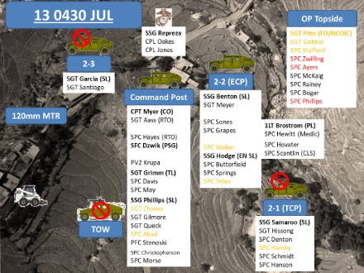
Slide 60. 130430 JUL

  - 0430: SGT Pitts reports the four casualties in OP Topside and advises the attackers are within 100m of the concertina wire. He tries to get the M240 into operation, but is hampered by the effects of his wounds.

    - At FOB Blessing, the 1st Platoon QRF is alerted and prepares to move to COP Kahler’s defense.

    - In 2nd Squad’s position, Brostrom has a short conversation with the squad leader, SSG Benton, and takes SPC Jason Hovater with PFC Hewitt to OP Topside. He may also have taken SPC Jeffrey Scantlin, a trained Combat Lifesaver.

    - (60-1) Just a few steps out of the 2nd Squad position, Hewitt is shot through the arm and returns to the CP. Brostrom and Hovator continue, undaunted, to the OP.

    - In the CP, they are still terribly busy managing the fight.

    - (60-2) SPC Jeffrey Scantlin, who likely stayed with Hewitt after he was shot, hands off his SAW and takes over for the wounded Hewitt.
      - Throughout the fight, Scantlin skillfully treats the wounded in the COP.
      - But despite his best efforts, SPC Abad succumbs to the effects of his wounds.

    - By this time, CPT Myer and the two RTOs in the CP have transmitted the first MEDEVAC request, in addition to requesting Close Air Support (CAS) and controlling the artillery fires.

    - At the same time, Brostrom and Hovater are sprinting together through intense fire, moving between the bazaar and the hotel complex, then scrambling up the terraces to the sleeping terrace in the OP.

Move from 2nd Squad’s position to OP Topside, following the route used by Brostrom and Hovator as shown below. Hug the bazaar wall and turn right where it ends, then move to OP Topside.

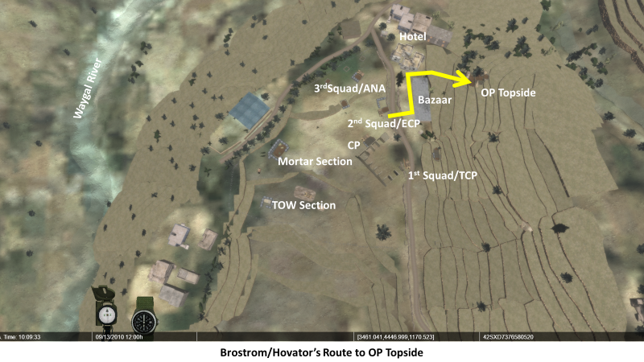

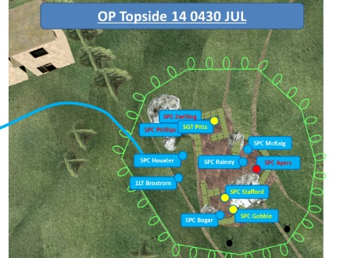
Slide 61. OP Topside 130430 JUL

      - (61-1) Brostrom calls out to Pitts and orders him to hand over the M240 and its ammunition.
        - Rainey joins them on the sleeping terrace.
        - It is possible that Brostrom was trying to place the M240 where it could return fire at the hotel and bazaar, which would have covered additional reinforcements as they came up.

Rotate from your position on OP Topside to observe the hotel.

        - According to SPC McKaig, after hearing Brostrom’s voice, they all felt more secure, “as if everything will work out just fine.”
      - (61-2) While Brostrom and Rainey are placing the M240 into action and Hovater provides security, they are surprised by insurgent fire from or near the large rock on the northwest corner of the OP. All three are killed by small arms fire.
      - (61-3) At some point during or soon afterwards, SPC Bogar, who was known in the platoon to be utterly fearless, steps out of the OP and attempts to suppress the incoming fire and starts engaging insurgents in the bazaar and the hotel. Soon after he is killed by enemy fire.

    - SPC McKaig is now the only soldier in the OP who is not dead or seriously wounded.
      - He has two magazines left for his M4 and decides to conserve them.
      - He throws two hand grenades to the southeast and two more into the dead space to the northeast.

Move into the Southern position on OP Topside.

    - He slides down to where Gobble and Stafford are, and finds the M72 LAAW.
      - He tries to fire it at insurgents shooting at them from a mud hut about 40 meters to the southeast, but it does not fire.
      - Gobble tells him to pull harder on the safety, and it works.
      - McKaig leans out, fires the rocket into the mud huts, and the shooting stops.

    - (61-4) Gobble and McKaig cannot get SGT Pitts to respond to their shouts and assume he has died of his wounds.
      - Stafford has lost a lot of blood and desperately needs evacuation.
      - They decide to abandon the OP, and push over the western wall of sandbags to the sleeping terrace, then move southwest towards 1st Squad.

Move from the Southern position on OP Topside to the HESCO barriers at 1st Squad’s position as indicated by the yellow arrow.

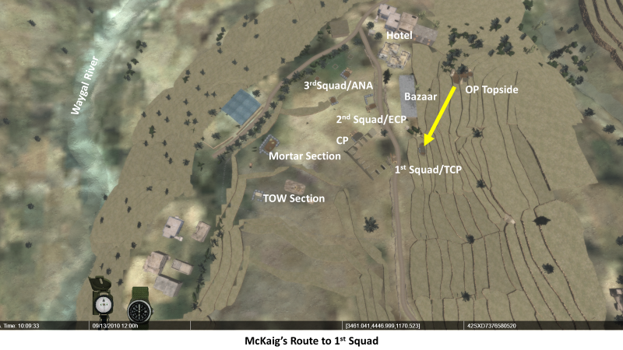

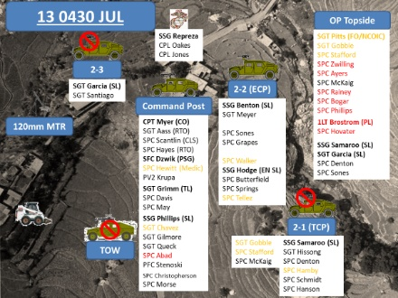
Slide 62. 130430 JUL

    - Down at 1st Squad’s TCP, SSG Samaroo decides to reinforce OP Topside a short time after Brostrom and Hovater left 2nd Squad’s position and their arrival at OP Topside. He grabs SPC Hanson and PFC Hamby and leaves their position.
      - (62-1) Samaroo’s party meets Stafford, Gobble, and McKaig on their way up, and pause to help them to the TCP.
      - Hanson and Hamby stay with the wounded OP defenders, and Samaroo takes SGT Garcia, SPC Denton and PFC Sones back up with him.

Turn around and move back up into OP Topside. Move into the Crow’s Nest position.

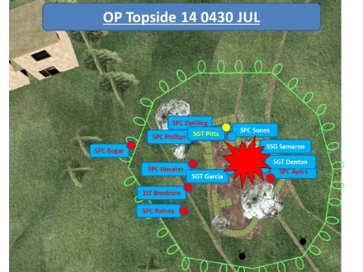
Slide 63. OP Topside 130430 JUL

    - The four of them counterattack and regain control of the OP. They put the M240 back into action in the crow’s nest, assess casualties, and re-establish security.

    - But soon after, small arms fire from all directions and RPGs quickly overwhelm their defense.
      - SGT Garcia is mortally wounded by an RPG that strikes him just below his body armor.
      - Sones is also wounded by RPG fire and hand grenade shrapnel.
      - Denton receives wounds to his right hand and both legs.
      - Samaroo is also wounded, but provides an updated SITREP to the CP.

SGT Pitts, in spite of his severe wounds, remembers what happened:

[Sergeant] Garcia was pulling security in the middle area and keeping a lookout. Sones was treating me against the north wall. I was sitting down and he was bandaging me up. That’s when another volley of RPGs and hand grenades came in. I was hit again, as was Sones. That’s when Garcia took a direct hit from an RPG. I thought he was dead from his wounds. I knew Samaroo and Denton were wounded and I could hear Samaroo screaming that he was hit. I don’t remember much after that. I do know that I crawled over to Garcia and talked to him some. Sones and I crawled into the southern position and Samaroo and Denton jumped in as well. I told them that Garcia was messed up. I don’t remember who did it but one of them dragged Garcia into our position. Samaroo needed a radio so I got an MBITR up so we could talk [to the COP]. He told them we needed more people and that they were wounded.

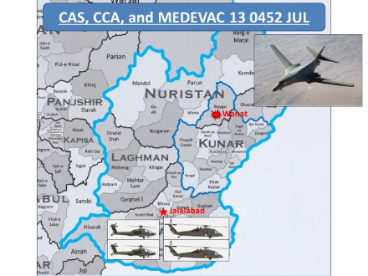
Slide 64. CAS, CCA, and MEDEVAC 130452 JUL

  - 0452: A few minutes after SSG Samaroo’s reinforcements reach OP Topside, the requested CAS is on station.

    - In Jalalabad, two AH-64’s take off with two MEDEVAC UH-60s.

    - Within a few minutes, the first of 38 precision-guided bombs are dropped on targets around COP Kahler by an Air Force B-1 bomber.

    - The bombs and artillery help set conditions for another reinforcing element to move up to the OP without receiving effective enemy fire.

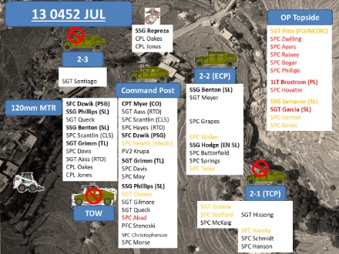
Slide 65. 130452 JUL

    - When Garcia was mortally wounded he fell onto his MBITR mike, accidentally jamming the platoon frequency with what is called a “hot mike” for a few minutes until it the problem rectifies itself.

    - At the CP, concerned by the jamming at a critical time, SFC Dzwik assembles the third group of reinforcements for OP Topside.
      - Dzwik gathers SSG Phillips and mortarman SGT Queck, the 2nd Squad Leader SSG Benton, PFC Scantlin (also 2nd squad but acting as platoon medic), SGT Grimm and SPC Aaron Davis from the TOW crew, Myer’s Radio Telephone Operator (RTO) SPC Aass, and the Marines CPL Oakes and Jones with their M240 machine gun.
      - Dzwik leads them on a less direct route to the OP via 1st Squad’s TCP to take advantage of better cover and concealment from enemy fire.
        - SPC Reid Grapes guides them the rest of the way to the OP, avoiding known enemy positions and fields of fire.
        - He obscures the last movements with yellow smoke grenades thrown into the open area near the hotel that must be crossed.

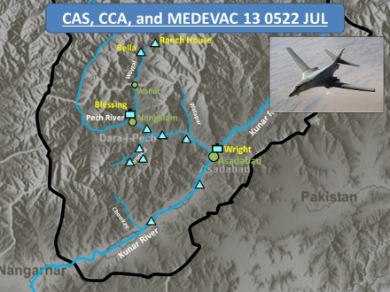
Slide 66. CAS, CCA, and MEDEVAC 130522 JUL

  - 0522: The Apaches arrive on station and begin Close Combat Attack (CCA) directed by CPT Myer against insurgent positions. The MEDEVAC helicopters land at the FOB Blessing Forward Arming and Refueling Point (FARP), but keep their rotors turning until the Apaches can suppress or neutralize threats to those aircrews.

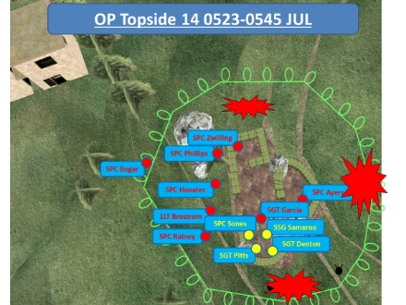
Slide 67. OP Topside 130523-0545 JUL

  - 0523: The Apaches make their first attack, a strafing pass against the north side of the brushy area immediately adjoining OP Topside.

    - After the arrival of the Apaches and SFC Dzwik’s reinforcements occupy OP Topside, the OP is never again in serious danger of being overwhelmed, but the fighting there is still intense.

    - The 1st Platoon QRF departs FOB Blessing.

One of the Apache pilots, CW3 Brian Townsend (call sign Hedgerow 53) remembers their role in the fight:

The helicopter in itself, a lot of times, is a pretty good deterrent for guys to stop shooting. I had no idea how many guys were on the ground shooting. I didn’t know how many were in the area. I just knew it was pretty chaotic. I came down pretty low and fast on the first pass because I didn’t know what I was going to be dealing with. I put down 30 or 40 rounds in an area where we discussed and thought that was the best place to start shooting. Did I see any enemy right there? No. Was it a fortified position with bad guys? No. It might have just been an open field or open area. That’s where I put the rounds down and of course Jimmy was right behind me coming in. For a long time it consisted of that.

We had 76 rockets, 600 rounds of 30mm, and each bird contained two missiles, so we had four Hellfires. We expended all of that.

    - (67-1) SPC Davis is badly wounded by an RPG impact.

    - SFC Dzwik receives a minor wound in his arm from a different RPG impact.

    - CPL Oakes, one of the Marines, is similarly struck and wounded.

    - Within a few minutes, the battle is at a point where CPT Myer can quickly move to the OP to make his own assessment of the perimeter’s condition.
      - He confirms the casualty reports and selects a suitable LZ for the MEDEVAC helicopter.
      - Then he returns to the CP and continues directing the defense, CAS, CCA, and MEDEVAC.

  - 0545: Under fire, MEDEVAC lifts out the first five of 2nd Platoon’s casualties from the LZ in COP Kahler.

  - 0558: The 1st Platoon QRF with 19 soldiers in four up-armored HMMWVs drives into COP Kahler and begins the counterattack.

ANALYSIS.

- Compare the Insurgent attack plan with its execution. How effective was their use of the human and physical terrain? What actions from 2nd Platoon, if any, forced the insurgents to alter their plan?

- Now compare 2nd Platoon’s defensive plan with its execution. How effective was their use of the human and physical terrain? What actions from the insurgents, if any, forced 2nd Platoon to alter their plan?

- Who had the initiative the morning of 13 July 2008? How long did they possess it? When did the initiative shift and to whom?

- Would getting the ANP to establish their OPs have produced a different outcome?

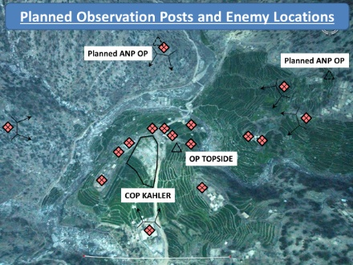
Slide 68. Planned Observation Posts and Enemy Locations

- Those planned OP locations were used by or very near the insurgents for SBF positions. Given the insurgents’ use of the physical terrain and what you currently know, do you think it might have changed the outcome?

Stand 6: Counter-Attack and Withdrawal

Visual | Virtual Views
70. Counterattack 130558 JUL
71. Reinforcements 13-14 JUL

ORIENTATION. NA

DESCRIPTION.

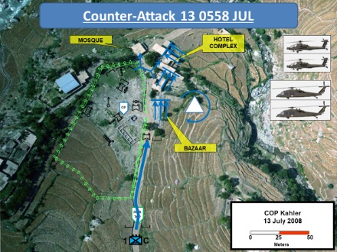
Slide 70. Counterattack 130558 JUL

- Counterattack.

  - 0558: (70-1) First Lieutenant Aaron Thurman and his platoon sergeant, SFC William Stockard, with Chosen Company’s first sergeant, 1SG Scott Beeson and 16 soldiers in four up-armored HMMWVs finish the normally 90-minute drive to COP Kahler in 45 minutes. They fire their heavy weapons into every known or suspected ambush position and IED site to maintain their speed.

    - Despite the advantage in firepower from the Apaches, heavy fire is still pouring into COP Kahler from the bazaar, hotel, and mosque.

    - Two QRF soldiers are dropped off at the TCP to augment its defenders, and the platoon medic runs directly to the Casualty Collection Point (CCP) at the CP to assist there. Beeson and his RTO check in with CPT Myer, who dispatches them to OP Topside.

    - (70-2) 1LT Thurman splits his small platoon into two sections.
      - One accompanies him to clear the bazaar.
      - The other, under Stockard, goes with Beeson to the OP.
      - Two of the four HMMWVs remain at the TCP.

    - (70-3) The other two HMMWVs charge forward past the bazaar and stop close to the hotel and mosque.
      - After Thurman’s section sweeps the bazaar of enemy fighters, they turn their attention to the hotel.
      - SSG Kyle Silvernale and a fire team from Thurman’s section find a place to climb through a second story window into the hotel, throwing frag grenades into each room before clearing it.

    - Up at the OP, Beeson and Stockard’s section strengthens OP Topside, but they are still receiving fire from at least three places and insurgents in the dead space around it as the insurgents press another attack. Grenades thrown into the dead space halts the pressure from insurgents in close proximity.

    - After Silvernale’s team finishes clearing the hotel, the remaining insurgents are out in the open.
      - Thurman orders Silvernale to throw yellow smoke grenades onto identified enemy positions to mark them as targets for the Apaches.
      - The Apaches respond quickly, firing within several meters of friendly troops.

    - After that the Apaches turn their attention to the compounds threatening OP Topside.
      - The first Hellfire missile impacts the large compound across Wayskawdi Creek to the northeast.
      - It burns, but continues to be used to fire on the OP.
      - Sometime later, an exasperated order to “level the buildings” is issued.
      - A second missile finishes the job.

  - 0605: Air MEDEVAC lands to evacuate four more casualties from the LZ near OP Topside.

  - 0615: Two additional air MEDEVAC helicopters have entered the rotation, taking casualties to the medical facility at FOB Wright in Asadabad. Five more casualties are evacuated, including the badly burned ANA soldier.

SGT Pitts remembered the courage and professionalism of the MEDEVAC crews:

I’ve seen a lot of MEDEVACs but I’ve never seen anything like what they did. It was one of the most amazing things I’ve ever seen. I actually wrote the crew chief of the bird I was on. I couldn’t believe the pilots landed where they did, that exposed. I couldn’t believe it. The Apaches were doing gun runs about 30 meters away.

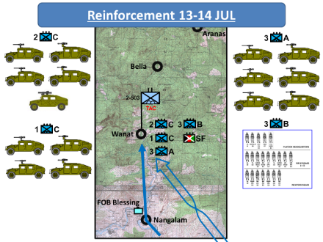
Slide 71. Reinforcements 13-14 JUL

- Reinforcement. During this time, TF Rock sends additional reinforcements to COP Kahler as transportation assets became available.

  - 0720: (71-1) Six HMMWVs in a team from Able Company under CPT David Nelson arrive with his 3rd Platoon and a scout section from the battalion’s scout platoon. CPT Myer turns command of COP Kahler over to Nelson.

  - 1330: (71-2) As soon as CPT Daniel Kearney heard CPT Myer say, “this is a Ranch House-style attack”, he issues a Warning Order (WARNO) to his company for an impending move to Wanat.

    - His 3rd Platoon, under 1LT Michael Moad, arrives by CH-47 Chinooks at 1330 with the TF Rock TAC and the S3, MAJ Scott Himes.

    - CPT Nelson assigns responsibility for OP Topside to Moad.

  - Later in the afternoon, LTC Ostlund flies to Wanat with BG Milley.

    - Milley had flown to FOB Blessing earlier that day at the urging of MG Schloesser, CJTF-101 Commanding General.

    - They later return to FOB Blessing.

  - (71-3) Additional assets flow into Wanat throughout the day, including a large force of ANA Commandos and their US Special Forces advisor team.

  - The next day, 14 July, a platoon of pathfinders from the 101st Airborne Division joins the defense.

    - They meticulously searched every house in Wanat, gathering a considerable amount of intelligence. But the biggest surprise was found in the Wanat District Center:
      - In the headquarters of the 20-man ANP force was a large arsenal of weapons, and the majority had been recently fired.
      - Also present was a large quantity of 7.62mm ammunition and RPGs.
      - This discovery was strong evidence of ANP collusion with the insurgents.

SGT Grimm had a chance to visit the district center after the battle and recalled:

In the Wanat ANP compound I saw it was untouched [his emphasis], though it was on the ingress/egress route of the AAF [Anti-Afghan Force] that attacked from the mosque and bazaar. I saw a lot of expended brass inside their perimeter, southwest side (facing us). ANA Commandoes found a lot of bloody uniforms. All the ANP were in fresh brand new uniforms, which is unusual since they are only issued one uniform and are usually they are dirty. They also appeared freshly shaven with razor nicks on their faces. There were also over 100 weapons, including AKs, PKMs, RPKs, RPGs, pistols, and shotguns. They were dirty and had been recently fired.

    - Other searched buildings yielded stashes of medical supplies, hand-held radios, floodlights, blasting caps, detonator cord, and a video camera with the tape still in it.

  - The force at Wanat now numbers over 200 armed Coalition fighters. Sporadic fighting continues until 15 July.

- Withdrawal.

  - On 14 July, LTC Ostlund gave MAJ Himes a pair of alternatives: either continue with construction of a permanent COP in Wanat or withdraw from the town.

  - COL Preysler and the CJTF-101 staff presented MG Schloesser with four Courses of Action regarding Wanat and COP Kahler: attack, withdraw, hold, or battle-hand-off to TF Duke.

  - Just as a variety of factors had influenced the decision to establish COP Kahler at Wanat, a range of factors influenced a decision to evacuate.

  - CPT Myer recommended a withdrawal:

After the fight on July 13th in Wanat, the situation for occupation was drastically changed. No matter how much Coalition forces conducted IO to explain/battle the circumstances for occupation of Wanat, it would be viewed as hostile. The population in and around Wanat clearly supported the enemy and did not maintain the conditions for Coalition force support and projects. Wanat is ideal because of the ground LOC open to the rest of the [battalion] but that would take significant manpower to keep open.

  - LTC Ostlund also recommended a withdrawal.

Working [the lines of operation] was going to take an incredible influx of resources for security. The district governor was going to need to be replaced, the market was shot up [in fact one stall of the bazaar was burned to the ground] and we were not going to reward the area with $1.4 million in projects. The conditions changed radically on the morning of 13 July 2008 and the Wanat population priced themselves out of our desire to assist them at that time.

  - The CJTF-101 S2 section recommended maintaining a presence in the Waygal Valley to prevent interference in the Pech Valley.

  - Taking Myer’s and Ostlund’s recommendations into account, MG Schloesser described the process he used to reach the final decision:

The next day, the 14th, I had a staff recommendation from my staff at the CJTF level. When Preysler briefed me, he had Ostlund’s as well as Captain Myer’s recommendations, and they were all to evacuate. This is Myer’s recommendation to me: “After 13 July, the tactical problem set reference, geography and human terrain changed. The land is no longer technically tenable. We need more defensible land, which would displace the population and require a much larger force to hold and build. The population proved corrupted or intimidated. The land and human terrain are no longer tenable.” He states it tactically, but operationally, when I took that thought process – and again, Ostlund felt the same way, so did Preysler. They weighed it against what we were actually able to achieve with the people there in the Waygal Valley and it didn’t make good tactical or operational sense to maintain that presence.

  - On 15 July 2008, instructions came down from CJTF-101 through TF Bayonet to TF Rock to evacuate Wanat.

ANALYSIS.

- Consider 1LT Moad’s opinion of OP Topside and the opinion of SFC Barbaret (his platoon sergeant), and contrast it with those of SFC Dzwik and SGT Pitts:

SFC Barbaret: “My initial perception on the battlefield was, why are we in the low ground, where are the fortifications, and why don’t we own any high ground?”

1LT Moad: I took the remainder of my platoon [from OP Topside] to the large compound about 150 meters to the east of OP Topside in the high ground. The compound offered dominating observation above the village of Wanat and a good majority of avenues of approach into the proposed Combat Outpost. Moreover, this position was previously used as an attack position against Chosen Company evident by the large amount of expended AK-47 brass. Lastly, we were not actually the first to this location; however, one squad from the Able Company QRF had occupied and maintained this position until we relieved them in the mid-afternoon.

- What is different? What are 1LT Moad’s and SFC Barbaret’s conclusions regarding human and physical terrain in their choice of OP locations? Why would two different platoon leaders and platoon sergeants arrive at different conclusions about the same terrain?

- A large weapons cache, much larger than required for a 20-man ANP contingent, was found in their building (which was untouched by the battle.) It was a strong indication of ANP cooperation or collusion with the insurgents who attacked COP Kahler. Given the insurgents’ use of the human terrain and what you currently know, would getting the ANP to establish their OPs have produced a different outcome?

- Which is more important in counterinsurgency, the human terrain or the physical terrain? Can you place tactical or operational emphasis on one without risking the other?

- Do you agree or disagree with the recommendations to abandon COP Kahler? Why or why not?

Stand 7: Integration

Instructor’s Note: The questions listed below do not constitute the limits of discussion for the Integration Phase of the Virtual Staff Ride. Instead, these questions are a compilation of those most commonly asked by the Staff Ride Team or its training audiences since the introduction of the Wanat VSR. If the VSR is focused on an individual aspect of the battle from the perspective of the Warfighting Functions (Mission Command, Maneuver, Fires, Protection, and Sustainment), the Integration Phase may use questions developed specifically for that purpose with the training audience in mind. Also, feel free to revisit the virtual terrain if needed to help the training audience reach their conclusions or make additional points.

- Often, training audiences begin the Wanat VSR after the Preliminary Study Phase with an opinion or opinions of the battle and its outcome. Has your opinion or have your opinions changed after the Field Study Phase of the staff ride? Why or why not?

- What difficult choices did the leadership in 2nd Platoon, Chosen Company, TF Rock, and/or TF Bayonet make regarding Coalition presence in the Waygal Valley? What makes the complexities of counter-insurgency so challenging in the decision-making process for leaders? Is decision-making in Unified Land Operations any less challenging, or are the challenges just different?

- How often does the US Army make rapid changes in orders and decisions that affect its subordinate commands and units? How disruptive are those changes? How do we as leaders work to minimize the negative effects of those changes? At what point do you, as a leader, step up and voice your reservations and to whom?

- OPERATION ROCK MOVE was conducted as the first elements of TF Duke arrived in AO Rock. Could there have been a course of action that integrated them into the establishment of COP Kahler’s defenses as part of the RIP/TOA? What are the risks of that course of action? Would it have been suitable, feasible, or acceptable to use that course of action?

- Could TF Rock’s redeployment been delayed long enough to establish a better foothold in Wanat? Who has that authority, and how long does it take to get their decision? Would it have meant a different outcome?

- Was TF Rock’s experience in Afghanistan any different from that of the Soviets between 1978 and 1980? The British in 1919? The British between 1878 and 1881? Or the British between 1839 and 1842?

